




Clean and prepare rooms for incoming guests
D1.HHK.CL3.03
Trainee Manual


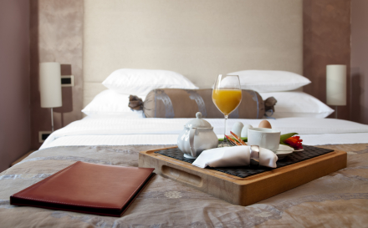

Clean and prepare rooms for incoming guests

D1.HHK.CL3.03

Trainee Manual





Project Base
William Angliss Institute of TAFE
555 La Trobe Street
Melbourne 3000 Victoria
Telephone: | (03) 9606 2111
Facsimile: | (03) 9670 1330
Acknowledgements
Project Director: | Wayne Crosbie
Chief Writer: | Alan Hickman
Subject Writer: | Nick Hyland
Project Manager: | Alan Maguire
Editor: | Jim Irwin
DTP/Production | Daniel Chee, Mai Vu, Jirayu Thangcharoensamut, Kaly Quach

The Association of Southeast Asian Nations (ASEAN) was established on 8 August 1967. The Member States of the Association are Brunei Darussalam, Cambodia, Indonesia, Lao PDR, Malaysia, Myanmar, Philippines, Singapore, Thailand and Viet Nam.
The ASEAN Secretariat is based in Jakarta, Indonesia.
General Information on ASEAN appears online at the ASEAN Website: www.asean.org.
All text is produced by William Angliss Institute of TAFE for the ASEAN Project on “Toolbox Development for Priority Tourism Labour Division”.
This publication is supported by the Australian Government’s aid program through the ASEAN-Australia Development Cooperation Program Phase II (AADCP II).
Copyright: Association of Southeast Asian Nations (ASEAN) 2012.
All rights reserved.
Disclaimer
Every effort has been made to ensure that this publication is free from errors or omissions. However, you should conduct your own enquiries and seek professional advice before relying on any fact, statement or matter contained in this book. The ASEAN Secretariat and William Angliss Institute of TAFE are not responsible for any injury, loss or damage as a result of material included or omitted from this course. Information in this module is current at the time of publication. Time of publication is indicated in the date stamp at the bottom of each page.
Some images appearing in this resource have been purchased from stock photography suppliers Shutterstock and iStockphoto and other third party copyright owners and as such are non-transferable and non-exclusive. Clip arts, font images and illustrations used are from the Microsoft Office Clip Art and Media Library. Some images have been provided by and are the property of William Angliss Institute.
Additional images have been sourced from Flickr and SXC and are used under Creative Commons licence: http://creativecommons.org/licenses/by/2.0/deed.en

File name: TM_Clean_&_prepare_rooms_for_incoming_guests_refined





Table of Content
Introduction to trainee manual 1
Unit descriptor 3
Assessment matrix 5
Glossary 9
Element 1: Identify the role of room attendants 11
Element 2: Prepare for cleaning duties 26
Element 3: Make beds 45
Element 4: Clean bathroom 55
Element 5: Clean room 63
Element 6: Provide additional housekeeping services 91
Element 7: Prepare for next shift 99
Presentation of written work 109
Recommended reading 111
Trainee evaluation sheet 113
Trainee self-assessment checklist 115

Introduction to trainee manual

To the Trainee
Congratulations on joining this course. This Trainee Manual is one part of a ‘toolbox’ which is a resource provided to trainees, trainers and assessors to help you become competent in various areas of your work.
The ‘toolbox’ consists of three elements:
- A Trainee Manual for you to read and study at home or in class
- A Trainer Guide with Power Point slides to help your Trainer explain the content of the training material and provide class activities to help with practice
- An Assessment Manual which provides your Assessor with oral and written questions and other assessment tasks to establish whether or not you have achieved competency.
The first thing you may notice is that this training program and the information you find in the Trainee Manual seems different to the textbooks you have used previously. This is because the method of instruction and examination is different. The method used is called Competency based training (CBT) and Competency based assessment (CBA). CBT and CBA is the training and assessment system chosen by ASEAN (Association of South-East Asian Nations) to train people to work in the tourism and hospitality industry throughout all the ASEAN member states.
What is the CBT and CBA system and why has it been adopted by ASEAN?
CBT is a way of training that concentrates on what a worker can do or is required to do at work. The aim is of the training is to enable trainees to perform tasks and duties at a standard expected by employers. CBT seeks to develop the skills, knowledge and attitudes (or recognise the ones the trainee already possesses) to achieve the required competency standard. ASEAN has adopted the CBT/CBA training system as it is able to produce the type of worker that industry is looking for and this therefore increases trainees chances of obtaining employment.
CBA involves collecting evidence and making a judgement of the extent to which a worker can perform his/her duties at the required competency standard. Where a trainee can already demonstrate a degree of competency, either due to prior training or work experience, a process of ‘Recognition of Prior Learning’ (RPL) is available to trainees to recognise this. Please speak to your trainer about RPL if you think this applies to you.
What is a competency standard?
Competency standards are descriptions of the skills and knowledge required to perform a task or activity at the level of a required standard.
242 competency standards for the tourism and hospitality industries throughout the ASEAN region have been developed to cover all the knowledge, skills and attitudes required to work in the following occupational areas:
- Housekeeping
- Food Production
- Food and Beverage Service
- Front Office
- Travel Agencies
- Tour Operations.
All of these competency standards are available for you to look at. In fact you will find a summary of each one at the beginning of each Trainee Manual under the heading ‘Unit Descriptor’. The unit descriptor describes the content of the unit you will be studying in the Trainee Manual and provides a table of contents which are divided up into ‘Elements’ and ‘Performance Criteria”. An element is a description of one aspect of what has to be achieved in the workplace. The ‘Performance Criteria’ below each element details the level of performance that needs to be demonstrated to be declared competent.
There are other components of the competency standard:
- Unit Title: statement about what is to be done in the workplace
- Unit Number: unique number identifying the particular competency
- Nominal hours: number of classroom or practical hours usually needed to complete the competency. We call them ‘nominal’ hours because they can vary e.g. sometimes it will take an individual less time to complete a unit of competency because he/she has prior knowledge or work experience in that area.
The final heading you will see before you start reading the Trainee Manual is the ‘Assessment Matrix’. Competency based assessment requires trainees to be assessed in at least 2 – 3 different ways, one of which must be practical. This section outlines three ways assessment can be carried out and includes work projects, written questions and oral questions. The matrix is designed to show you which performance criteria will be assessed and how they will be assessed. Your trainer and/or assessor may also use other assessment methods including ‘Observation Checklist’ and ‘Third Party Statement’. An observation checklist is a way of recording how you perform at work and a third party statement is a statement by a supervisor or employer about the degree of competence they believe you have achieved. This can be based on observing your workplace performance, inspecting your work or gaining feedback from fellow workers.
Your trainer and/or assessor may use other methods to assess you such as:
- Journals
- Oral presentations
- Role plays
- Log books
- Group projects
- Practical demonstrations.
Remember your trainer is there to help you succeed and become competent. Please feel free to ask him or her for more explanation of what you have just read and of what is expected from you and best wishes for your future studies and future career in tourism and hospitality.

Unit descriptor
Clean and prepare rooms for incoming guests
This unit deals with the skills and knowledge required to Clean and prepare rooms for incoming guests in a range of settings within the hotel and travel industries workplace context.
Unit Code:
D1.HHK.CL3.03
Nominal Hours:
30 hours

Element 1: Identify the role of room attendants
Performance Criteria
1.1 Describe the services delivered by a room attendant
1.2 Locate the position of room attendants within the enterprise
1.3 Identify the personal characteristics required of a room attendant
1.4 Describe grooming and personal presentation standards for a room attendant
1.5 Interpret enterprise policies and procedures for the provision of housekeeping services
1.6 Identify and explain the role of communication in the provision of housekeeping services

Element 2: Prepare for cleaning duties
Performance Criteria
2.1 Replenish linen room supplies
2.2 Load housekeeping trolley with supplies for service
2.3 Check housekeeping trolley prior to use
2.4 Identify rooms to be cleaned for the shift
2.5 Access and enter guest room appropriately

Element 3: Make beds
Performance Criteria
3.1 Strip and re-make bed with fresh bed linen
3.2 Re-make bed using existing bed linen

Element 4: Clean bathroom
Performance Criteria
4.1 Clean bath and shower area
4.2 Clean toilets
4.3 Clean vanity area
4.4 Clean floors
4.5 Replenish guest supplies

Element 5: Clean room
Performance Criteria
5.1 Follow in-house requirements and policies in relation to room cleaning
5.2 Clean fixtures and fittings
5.3 Vacuum floors and other areas
5.4 Clean kitchenette area, where applicable
5.5 Replenish guest supplies
5.6 Check operational readiness of all items and equipment
5.7 Report and remedy room defects and damaged items
5.8 Report suspicious items or situations
5.9 Handle guest property left in room from which the guest has departed

Element 6: Provide additional housekeeping services
Performance Criteria
6.1 Provide turn-down service
6.2 Carry out rotational cleaning duties
6.3 Lend equipment to guests, as requested in accordance with house policies

Element 7: Prepare for next shift
Performance Criteria
7.1 Complete required records and notifications
7.2 Dispose of rubbish
7.3 Clean and store trolleys
7.4 Replenish stock items as necessary
7.5 Clean housekeeping equipment prior to storage

Assessment matrix
Showing mapping of Performance Criteria against Work Projects, Written Questions and Oral Questions
The Assessment Matrix indicates three of the most common assessment activities your Assessor may use to assess your understanding of the content of this manual and your performance - Work Projects, Written Questions and Oral Questions. It also indicates where you can find the subject content related to these assessment activities in the Trainee Manual (i.e. under which element or performance criteria). As explained in the Introduction, however, the assessors are free to choose which assessment activities are most suitable to best capture evidence of competency as they deem appropriate for individual students.
 |  |  | Work Projects | Written Questions | Oral Questions
Element 1: Identify the role of room attendants
1.1 | Describe the services delivered by a room attendant |  | 1.1 | 1 | 1
1.2 | Locate the position of room attendants within the enterprise |  | 1.1 | 2 | 2
1.3 | Identify the personal characteristics required of a room attendant |  | 1.1 | 3 | 3
1.4 | Describe grooming and personal presentation standards for a room attendant |  | 1.2 | 4 | 4
1.5 | Interpret enterprise policies and procedures for the provision of housekeeping services |  | 1.3 | 5 | 5
1.6 | Identify and explain the role of communication in the provision of housekeeping services |  | 1.1 | 6 | 6
Element 2: Clean and prepare rooms for incoming guests
2.1 |  | Replenish linen room supplies | 2.1 | 7 | 7
2.2 |  | Load housekeeping trolley with supplies for service | 2.1 | 8 | 8
2.3 |  | Check housekeeping trolley prior to use | 2.1 | 9 | 9
2.4 |  | Identify rooms to be cleaned for the shift | 2.2 | 10 | 10
2.5 |  | Access and enter guest room appropriately | 2.3 | 11 | 11
Element 3: Make beds
3.1 | Strip and re-make bed with fresh bed linen |  | 3.1 | 12 | 12
3.2 | Re-make bed using existing bed linen |  | 3.2 | 13 | 13
Element 4: Clean bathroom
4.1 |  | Clean bath and shower area | 4.1 | 14 | 14
4.2 |  | Clean toilets | 4.1 | 15 | 15
4.3 |  | Clean vanity area | 4.1 | 16 | 16
4.4 |  | Clean floors | 4.1 | 17 | 17
4.5 |  | Replenish guest supplies | 4.1 | 18 | 18
Element 5: Clean room
5.1 | Follow in-house requirements and policies in relation to room cleaning |  | 5.1 | 19 | 19
5.2 | Clean fixtures and fittings |  | 5.2 | 20 | 20
5.3 | Vacuum floors and other areas |  | 5.2 | 21 | 21
5.4 | Clean kitchenette area, where applicable |  | 5.2 | 22 | 22
5.5 | Replenish guest supplies |  | 5.3 | 23 | 23
5.6 | Check operational readiness of all items and equipment |  | 5.3 | 24 | 24
5.7 | Report and remedy room defects and damaged items |  | 5.3 | 25 | 25
5.8 | Report suspicious items or situations |  | 5.3 | 26 | 26
5.9 | Handle guest property left in room from which the guest has departed |  | 5.3 | 27 | 27
Element 6: Provide additional housekeeping services
6.1 |  | Provide turn-down service | 6.1 | 28 | 28
6.2 |  | Carry out rotational cleaning duties | 6.1 | 29 | 29
6.3 |  | Lend equipment to guests, as requested in accordance with house policies | 6.2 | 30 | 30
Element 7: Prepare for next shift
7.1 | Complete required records and notifications |  | 7.1 | 31 | 31
7.2 | Dispose of rubbish |  | 7.1 | 32 | 32
7.3 | Clean and store trolleys |  | 7.1 | 33 | 33
7.4 | Replenish stock items as necessary |  | 7.2 | 34 | 34
7.5 | Clean housekeeping equipment prior to storage |  | 7.3 | 35 | 35

Glossary
Term | Explanation
Chemical | A product, normally in liquid form, used to clean a surface
Clean | Free from dirt; unsoiled; unstained
Deodoriser | A product used to remove, disguise, or absorb odour, especially when unpleasant
Defect | A shortcoming, fault, or imperfection
Disinfectant | Any chemical agent used chiefly on inanimate objects to destroy or inhibit the growth of harmful organisms
Dry Cleaning | The cleaning of garments, fabrics, draperies, etc., with various chemicals rather than with water
Duvet | A quilt, or comforter, usually down-filled, often with a removable cover
Fittings | Anything provided as equipment in a guest room usually attached to ceiling, wall or floor
Furnishings | Movable items of furniture in a guest room, such as chairs and tables
Grooming | To tend carefully as to person and dress; make neat or tidy
Housekeeping | Cleaning and maintenance of for example, a house or guest rooms in an hotel
Kitchenette | A small kitchen or part of another room equipped for use as a kitchen
Laundry | Articles of clothing, bed linen, tablecloths or similar, that have been or are to be washed
Manual handling | The act of pushing, pulling or lifting
OSH | OSH refers to ‘Occupational Safety and Health. It relates to workplace health and safety policies, procedures and practices
Policy | A rule, a definite course of action
Polish | To make smooth and glossy, especially by rubbing or friction, usually with a cloth and an appropriate chemical
Procedure | A particular course or mode of action
RFID | Radio Frequency Identification Device. Used to identify information on a hotel room key card.
Strip | To remove bed linen from a mattress
Suite | Hospitality accommodation containing more than one room
Trolley | A transport vehicle used in housekeeping to move supplies from room to room
Twin room | Two beds in a room

Element 1:
Identify the role of room attendants

1.1 Describe the services delivered by a room attendant

Introduction
Room attendants are located in any tourism and hospitality business that provides accommodation to their guests. In many hotels and resorts, more people are employed as room attendants than any other front line position.
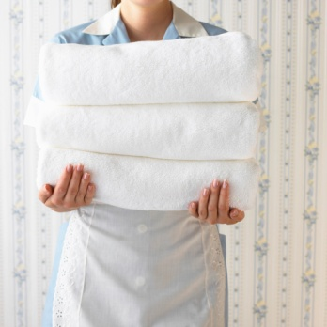
The role of a room attendant is important for a number of reasons.
It may not be regarded as a glamorous position like working in a bar or on the reception desk; however a customer experience is certainly impacted, in a positive or negative way, depending on how well a room attendant performs their job.
The job of a room attendant quite often goes unnoticed as their job is performed when the guest is not in the room. That said, the services they provide are experienced by every guest who stays in the hotel. Every guest will use most aspects of the room. They will sleep in the bed, clean their teeth at the basin, use the toilet and walk on the floor.
Rooms in hotels and resorts quite often accommodate different guests from one night to the next. However when a guest arrives, the room must appear as though no-one has stayed there before, with no exceptions.

Hotel and resort guests have high expectations of how a room should be cleaned and presented prior to their arrival. Every trace of past guests must be removed, down to single strands of hair and finger prints.
So what is the role of a room attendant? It is obvious their role is to clean guest rooms but there is more to the job than this.
Their role is to facilitate the comfort and satisfaction of guests by ensuring that their ‘home away from home’ is clean, safe and presented in an appealing manner.
Whilst their primary function is to clean they must also be friendly, informative, and discreet, and handle any requests or problems relating to the guest room.

Areas of responsibility
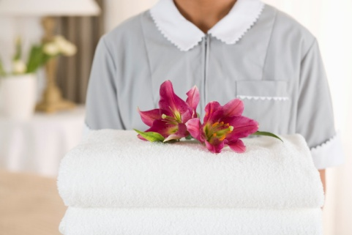
There are a number of areas of responsibility room attendants must manage as part of their role.
In summary they are responsible for the:
- Cleanliness and overall appearance of guest rooms
- Security of guest rooms and privacy of guests.
Guest Relations
Every employee of a hotel, including room attendants, is expected to warmly greet guests and to be friendly and professional.
In many cases they need to work independently from other colleagues and must handle any problems that arise, without the assistance or guidance of others.
If there is a complaint about the room or its furnishings or fixtures, in many cases the room attendant must not only handle to issue, but take ownership to ensure it is resolved in a timely manner.

Guest Safety
The job description of a room attendant includes ensuring the safety and well being of guests and their property.
Cleaning
They are required to ensure all aspects of a guest room are clean and tidy.
Administration & Communication
Room attendants must ensure they understand what rooms they are to clean and in which order. Administration and communication is vital to ensure rooms are returned ‘clean’ ready for new guests.

Daily activities
Following is a list of activities a room attendant may be required to complete on a daily basis. As you can see there are many activities a room attendant is responsible for in a normal work shift, involving a wide variety of knowledge and skills.
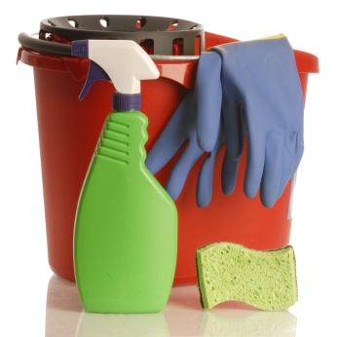
Prepare for work
- Collect master keys
- Collect daily room allocation sheets
- Stock housekeeping trolleys
- Stock and store supplies
- Determine the order of cleaning of rooms
- Identify any special requests.

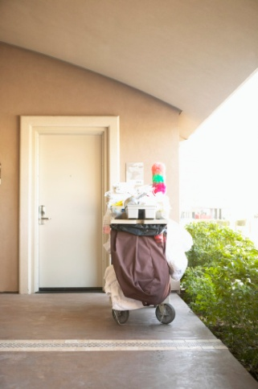
Enter room
- Knock on door in compliance with policy
- Open door
- Place trolley in door path.
Clean room
- Open curtains and windows for ventilation
- Remove used guest amenities and rubbish
- Clean showers, tubs, sinks and bathroom items
- Change linen and make beds
- Check for damaged linen items
- Inspect rooms for safety hazards and for the operating condition of equipment and report defects to the maintenance department
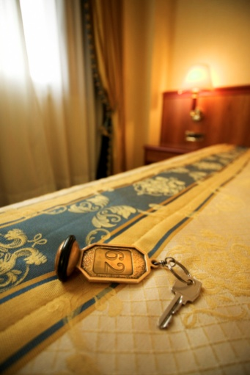
- Report lost and found articles, maintenance problems or special room problems
- Dust and clean room decorations, appliances and structural surfaces (wall fixtures, window sills, and vents)
- Dust, brush, polish vacuuming furniture.
- Replenish guest amenities and supplies
- Check, record and replenish mini bar
- Prepare rooms for guest arrival and respond to special guest requests, such as delivering newspapers or cleaning a spill.
- Deliver and retrieve items on loan to guests such as iron and ironing board
- Perform rotation cleaning duties (such as. steam clean of carpets) as required
- Vacuum and sweep carpets and other floor surfaces.
- Mop floor surfaces as needed.
- Record room status on work assignment sheets
- Phone supervisor or reception updating status of room
- Close door.

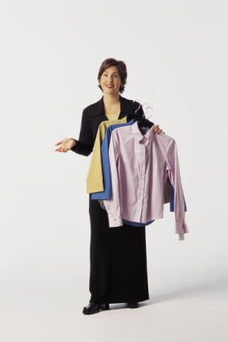
Provide information to guests
- Listen, and respond to guests’ requests or complaints
- Explain room equipment and facilities
- Explain and handle dry cleaning and laundry requests
- Provide information to guests about hotel services, facilities and other amenities
- Provide information to guests about local attractions, services and location of places for religious worship
- Other specific information may include prayer and fasting times, location of prayer mats and orientation for prayer.
Maintain storage areas and trolleys
- Return trolley to storage room
- Remove used and soiled linen from housekeeping cart
- Dispatch soiled linen to the laundry
- Replenish linen and guest amenities to normal stock levels on trolleys
- Handle lost property
- Clean cleaning equipment including mops and vacuum cleaners
- Remove rubbish
- Clean storage room floor.
Close shift
- Return work allocation sheets
- Return keys.
The following sections containing in this manual will look in detail, the steps and techniques used to successfully complete the necessary activities expected of room attendants.
It is commonly recognised that the role of room attendant is physically demanding and requires a wide scope of tasks to be performed. As such, it takes a special person to do the job well.

1.2 Locate the position of room attendants within the enterprise

Introduction
Room attendants
Where does the position of room attendant fit into the overall hospitality or tourism organisation?

Their department
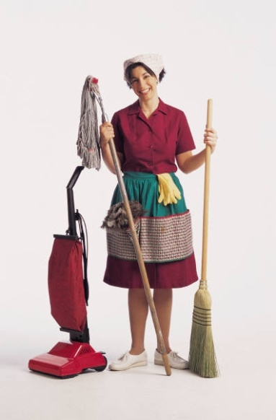
Room attendants work in the Housekeeping department. The Housekeeping department is the spine of the hotel, employing the most people and is responsible for:
- The cleanliness of the hotel – including all rooms and public areas. Public areas can include foyers, car parks, restaurants, hallways, gymnasiums and gardens
- Lost property – any items that have been lost or found by guests
- Laundry and dry cleaning – ensuring the cleanliness of guest items and all room linen, towels and uniforms.
In many hotels and resorts the Housekeeping department is part of Rooms Division. This division is responsible for all activities relating to accommodation including:
- Reservations – taking individual and group bookings

- Switchboard – handling incoming and outgoing calls, transfers and enquiries made by telephones within the hotel
- Reception – responsible for checking in and out of guests, finalising invoicing and payments, handling guest enquiries, and currency exchange
- Concierge and bell service – handling guest luggage, enquiries and valet services.

Their supervisor
A room attendant will usually report to will be a senior room attendant or a housekeeping supervisor. This person is responsible for the allocation of rooms to room attendants and to check rooms upon completion of cleaning by room attendants.
The head of Housekeeping is called the Executive Housekeeper. This person will report to the Rooms Division Manager.

1.3 Identify the personal characteristics required of a room attendant

Introduction
The role of a room attendant requires an individual who is able to complete a variety of tasks.
Whilst some of the personal characteristics of a room attendant are similar to those of anyone else working in the tourism and hospitality industry, there are also job specific skill sets that are required.

Knowledge
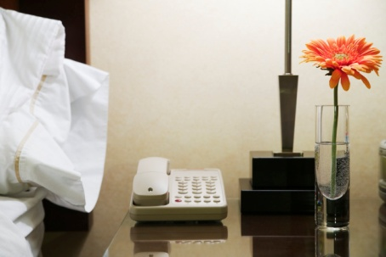
- Of working condition of all items – including televisions, air-conditioning systems, and internet access
- Of the hotel and room facilities – to be able to answer guest enquiries and to promote the hotel’s facilities and features
- Of use of cleaning equipment and chemicals
- Of correct procedures for cleaning a room
- Of safety and security.

Skills
- To be able to perform cleaning duties in a thorough and efficient manner
- To perform manual handling safely and efficiently.

Attributes
- Hard working
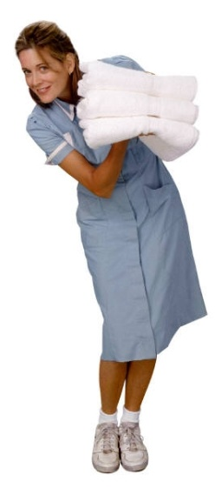
- Physically strong - mobility and stamina are required to clean for long periods of time
- Ability to follow instructions – most activities follow strict procedures
- Good time management – room attendants may be required to clean between 12 and 20 rooms per shift, without supervision
- Attention to detail – ability to ensure cleaning is performed to an extremely high standard
- Professional attitude
- Ability to work independently
- Previous customer service experience is an advantage
- Good communication skills
- Good organisational skills.

Importance of integrity, honesty and discretion
Whilst any role within the hospitality industry requires staff maintain a professional level of integrity, it is especially important in the housekeeping department, especially by those whom clean guest rooms.
It is important to remember that the guest room is a private area in which the guest can relax and enjoy the facilities. Essentially the guest room is a ‘home away from home’ for the guest. One of the main differences is that in hotels, this private space is frequented by hotel staff, with the room attendant spending considerable time performing cleaning duties.
The guest must feel that what takes place or is left in the room, will remain confidential.
For some guests, the guest room may be a place where activities may take place, which the guest may not feel comfortable undertaking at their own home or residence.
Naturally, if any action is in breach of local laws or regulations, the matter must be reported to management for further action. This includes the use of illegal drugs or activities that may place the guest and other patrons and staff under threat or harm.
Whilst you may not morally agree with any items or actions being undertaken in the room, as long as it is conducted in a legal manner, hotel staff must still be respectful to the privacy expected by guests.
Staff who enter occupied rooms must ensure that the integrity and confidentially of guests are upheld at all times. In addition, staff must ensure that their own actions are conducted in an honest and professional manner.
Therefore any hotel staff members who perform any activities in a guest room must not:
- Read confidential or personal information or examine items belonging to guests
- Use or consume guest items such as perfume or chocolates
- Share guest information with others
- Share information relating to guest activities to others.
Discretion is very important. Hotel staff must maintain the quality of being discreet, especially with reference to the guest’s and their own actions, speech, prudence or decorum.

1.4 Describe grooming and personal presentation standards for a room attendant

Introduction
A room attendant is an employee of the tourism or hospitality organisation, and employees are ‘the face of the business’ in the eyes of the guest.
Their appearance must be in line with company policy and professional industry standards.
Due to the demanding nature of the role, this can be more difficult. That said, high standards must still be maintained.
Not only does the organisation have set standards in terms of how it expects its staff to appear, the role will also dictate specific grooming requirements to ensure tasks can be completed in the most user-friendly manner.
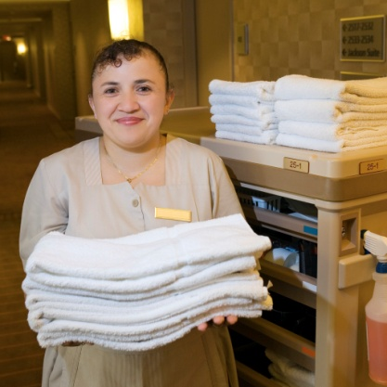
Hygiene and grooming are important to each staff member and the organization as a whole. A major part of success depends on a constantly well-groomed appearance. As room attendants are in the public eye they must maintain a conservative, tasteful and professional appearance that is consistent with the ambiance of the organisation.
In all aspects of grooming, room attendants should reflect expectations of the guest and the property. Most organizations will have strict grooming standards to ensure consistency, build confidence and pride of staff and to uphold a professional image.

Grooming & personal presentation standards
Whilst each organisation will have their own specific standards, there are many that are similar. These will be explored in this section.
Clothing
All clothes should be:
- Clean at the start of each day
- Replaced if soiled to a unsuitable standard
- Worn in the correct manner and
- Shoes to be suitable for the role.
Name Badge
- A staff member must wear their name badge at all times
- This is normally worn on chest on the left.


Hair
- Short and neat cut hair for men
- Tight or pulled back hair for women
- Natural hair colour
- Men to have well trimmed facial hair or to be clean shaven.
Nails
- Short and well trimmed
- No bright nail polish
- Cleaned on a regular basis.
Jewellery
- One dress ring or wedding ring
- Suitable watches
- No other jewellery such as bracelets, earrings, nose rings or necklaces.
Make up
- No excessive make up
- No visible tattoos.
Odour
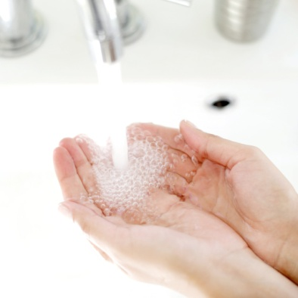
- No excessive perfumes
- Staff should use deodorant on a regular basis. This is important in a labour intensive role like cleaning rooms.
Personal hygiene
- Bathe or shower before work
- Teeth must be brushed
- Hands and face must be washed and cleaned.
Personal belongings
- No personal bags in work areas
- No mobile phones.
Whilst the physical demands of being a room attendant may be more labour intensive than other roles, personal grooming and hygiene must still be consistent with all positions and departments in an organisation.

1.5 Interpret enterprise policies and procedures for the provision of housekeeping services

Introduction
Each organisation will have its own policies and procedures. To begin with, it important to define what policies and procedures are:
- Policy – rule or code of conduct
- Procedure – step by step instruction.
Policies and procedures are very important and must be adhered to. They help to ensure the health, safety, security and privacy of the organisation, its staff and guests, including their assets and belongings.

Examples of policies and procedures
Examples of housekeeping policies
- Zero tolerance of theft.
- Guest room doors must be open whilst cleaning is in progress
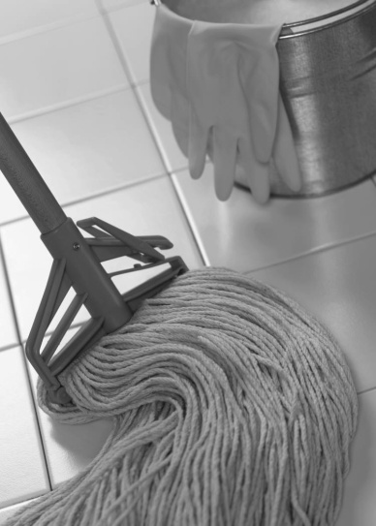
- Protective clothes to be worn when cleaning
- Guest information is confidential.
Examples of housekeeping procedures
- Accessing a room
- Making a bed
- Cleaning a window
- Cleaning a bathroom
- Mopping a floor
- Handling lost property.
Housekeeping will normally have more policies and procedures than most departments in a hospitality business because of:
- The nature of the work
- The need for detailed consistency in performance of all tasks
- Safety and security priorities.

Who creates policies and procedures
Policies and procedures may be created by:
- Housekeeping department – for specific use in that location
- Head office – for use throughout the chain of properties
- Manufacturers – to identify the correct methods for use and maintenance of products.

Types of policies and procedures
Policies and procedures in housekeeping normally relate to the correct handling, use, cleaning, storage and use of protective items relating to:
- Equipment – housekeeping cleaning equipment including vacuum cleaners, waxing machines, trolleys
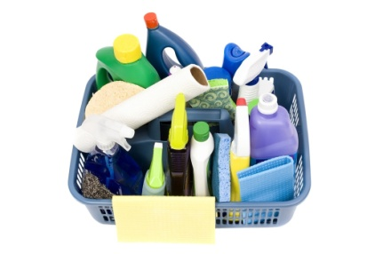
- Chemicals – including all cleaning products and items used to clean including cloths, rags, mops
- Furnishings – bedding, tables, couches, kitchens, televisions, carpets
- Fittings – lights, electrical appliances, air conditioners
- Clothing – uniforms and protective clothing.

Communicating policies and procedures
It is important all staff understand the policies and procedures that relate to their job. It is the responsibility of both management and staff to ensure these are understood.
There are a number of ways management can communicate policies and procedures including:
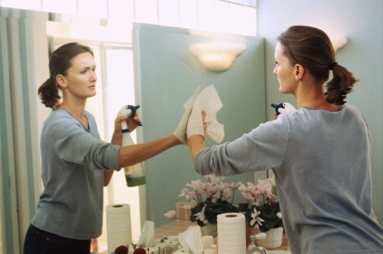
- Job Descriptions
- Training sessions
- Standard Operating Procedures
- Checklists and Task Sheets
- Observation by colleagues
- Supervision and instruction by management.

1.6 Identify and explain the role of communication in the provision of housekeeping services

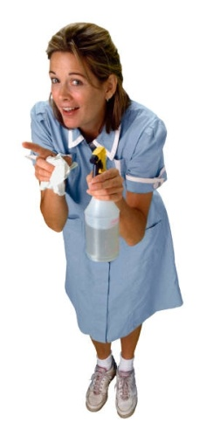
Introduction
As most staff will never enter a guest room except for a room attendant, it is important that room attendants are the eyes and ears for the hotel, either to update the status of rooms or co-ordinate any appropriate services to be performed, including maintenance, in a timely manner.
Hotel rooms make up a large majority of the actual space within a hospitality organisation and comprise a considerable financial investment. It is important that this asset is maintained in an organised, legal, safe and secure manner.
In many cases the role of room attendants plays a large part of meeting these goals. It is up to them to communicate and act when appropriate.

Positions room attendants communicate with
So who do room attendants communicate with on a regular basis?
Whilst room attendants communicate with all staff members, there are certain positions with which they communicate with more than others.

Receptionists
Room attendants work closely with reception for a number of reasons including:
- To identify vacant rooms, and find out when guests have checked out so they can start cleaning vacant dirty rooms
- To report clean rooms - when rooms are clean and ready for new guests
- To handle special requirements - for incoming guests including VIPs
- To handle guest requests - relating to the room including such things as additional towels and pillows, buckets of ice and for laundry to collected
- To co-ordinate internet access.
House Attendants
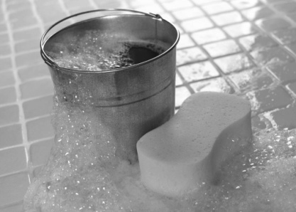
These people will normally be responsible for the distribution of items to/from from the housekeeping office to the store rooms on each floor, for easier access by room attendants.
These items include:
- Cleaning products - sprays, agents and cleaning clothes
- Equipment – buckets and mops
- Linen – bed sheets, pillow cases, blankets, bath towels, floor mats, hand towels and face cloths
- Room supplies – including shampoo, conditioners, stationery, matches, soaps etc
- Fresh produce – milk and biscuits to accompany tea and coffee facilities
- Removal of dirty items – soiled bedding and rubbish
- Collection or return of laundry or dry cleaning.
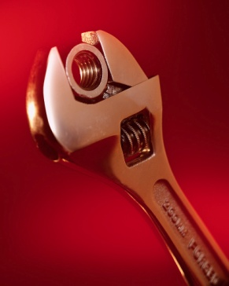
As a room attendant will normally be stationed on a selected floor, they will communicate with house attendants if items need to be replenished.
Maintenance
Room attendants will often call maintenance to fix or replace light bulbs and any faulty furnishings or equipment. In many cases these calls will be made relating to faulty televisions and air conditioning.
Mini Bar
In some organisations, the room attendant may be responsible for replenishing mini bar items and charging them to the guest rooms. In others this is performed by others as a separate mini bar service.
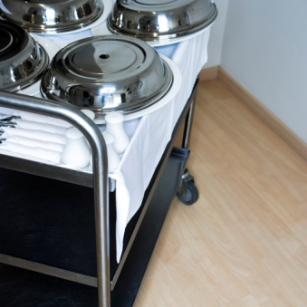
Room Service
When cleaning rooms, room attendants will remove used room service trays which must be placed out of guest sight and placed in the appropriate storage area on each guest floor. They will communicate with room service for the trays to be collected from the storage areas.
Security
With room attendants spending the majority of their shift working on guest floors, it is their responsibility to observe activities that take place around them. They must constantly listen and watch to ensure guest activities are conducted in a safe and secure manner. If there are any issues which they cannot resolve, security must be contacted without delay.

Work Projects
It is a requirement of this Unit that you complete Work Projects as advised by your Trainer. You must submit documentation, suitable evidence or other relevant proof of completion of the project to your Trainer by the agreed date.
1.1 To fulfil the requirements of this Work Project you are asked to research and identify:
- Services performed by a room attendant in a five star hotel
- How it differs from tasks provided by a room attendant in a budget hotel
- How a room attendant fits into a Housekeeping department including identification of their managers and colleagues
- Personal characteristics required by a room attendant
- Who room attendants communicate with and why
1.2 To fulfil the requirements of this Work Project you are asked to research, identify and collect organisational documentation regarding:
- Grooming expectations
- Personal presentation standards
1.3 To fulfil the requirements of this Work Project you are asked to research, identify and collect organisational documentation (Job descriptions, SOP’s & training materials, regarding:
- Housekeeping policies
- Housekeeping procedures

Summary

Identify the role of room attendants
Describe the services delivered by a room attendant
- Areas of responsibility
- Daily activities.
Locate the position of room attendants within the enterprise
- Their department
- Their supervisor.
Identify the personal characteristics required of a room attendant
- Knowledge
- Skills
- Attributes
- Grooming & personal presentation standards.
Interpret enterprise policies and procedures for the provision of housekeeping services
- Examples of policies and procedures
- Who creates policies and procedures
- Types of policies and procedures
- Communicating policies and procedures.
Identify and explain the role of communication in the provision of housekeeping services
- Positions room attendants communicate with.

Element 2:
Prepare for cleaning duties

2.1 Replenish linen room supplies

Introduction
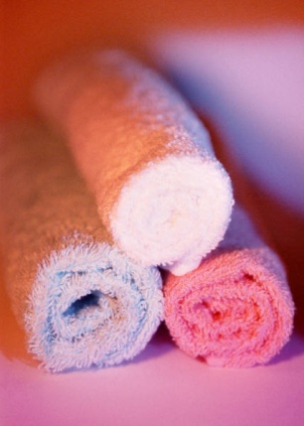
For most activities performed by a room attendant there are clear and precise instructions on how to perform the tasks.
In this section we will identify all the activities that will need to be performed before rooms are cleaned. As you will see, preparation is the key in ensuring rooms are cleaned in an efficient and timely manner. As room attendants often work in remote locations, not in close proximity to supplies, they must ensure they have all the necessary items at their disposal before they enter and clean rooms.
Before guest rooms are serviced, there is a need to prepare the linen room supplies and trolley that will be used to cart the cleaning materials and the room supplies to those rooms.
This section will also identify the equipment that needs to be selected and prepared, and identify the ‘rooms’ that may be involved when preparing guest rooms.

Need for adequate supplies
Having a well-equipped linen store is vital to efficiently and effectively servicing a guest room.
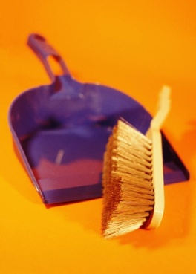
Supplies must be accurately identified and selected in sufficient numbers in order to service all necessary rooms. It is a waste of time to have to return to the housekeeping area for extra stock during cleaning and service duties.
In some cases, storage rooms on different floors may contain different supplies where for example, all rooms on the top two floors are ‘Penthouses’ and are stocked with better, more or different supplies.
Depending on the type of organisation, some supplies may be stored in suitable linen rooms or directly on trolleys. For the purpose of this manual these items will be explained in detail in this section.

Equipment
Various pieces of equipment are needed to service a guest room.
These are usually stored on a housekeeping store room on each floor – or in some central location.
Equipment that needs to be correctly selected and prepared before it is used may include:
Housekeeping trolley
A housekeeping trolley is sometimes called a ‘Maids’ trolley’.
Check to see it is clean, presentable, and safe. There should be no jagged bits, nothing should protrude to present a potential hazard, and the wheels should move easily and smoothly.
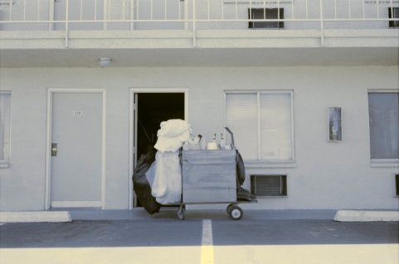
The trolley and all the equipment listed below are usually stored in a floor housekeeping store or linen room that also contains stocks of trolley supplies such as give-away items, spare light globes and toilet paper.
It is a standard industry requirement that nothing that is not part of the original design of the trolley is allowed to hang from the trolley such as plastic or other bags. Hanging extra items off the trolley certainly spoils and cheapens the appearance of the trolley as well presenting a possible obstruction or hazard. The trolley may be fitted with one or two large bags that are part of the original design – one bag for used linen and one bag for rubbish.
The floor housekeeping store room must be locked after you have taken your trolley and supplies out of it.
- http://www.trolleyworld.com.au/custom_made_trolleys.html
- http://www.industrysearch.com.au/Products/House_Maid_Trolley-21678.
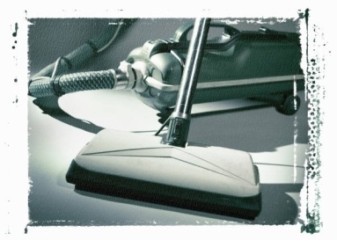
Vacuum cleaner
This must be checked to see it is empty at the start of the shift, spare bags are available (where appropriate), that the machine is fully functional and that there are no frayed cords or other safety problems. Check should also be made to ensure that all the vacuum machine tools/accessories that need to be used are available.
- http://www.powersweep.com.au/vacuum.htm
- http://www.nilfisk-advance.com.au/
- http://www.hostdirect.com.au/listProduct/Cleaning/Vacuum+Cleaners/.

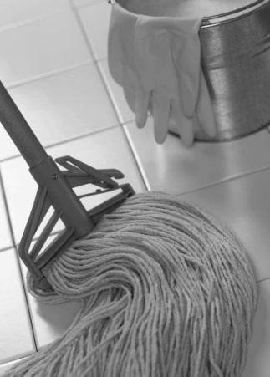
Mops
Ensure the mop head looks presentable as guests will be able to see this and may infer a lack of cleanliness in other or all cleaning from seeing a dirty mop head. Also ensure it has been sanitised to kill bacteria. Mops may include wet mops for washing floors and dry mops for polishing and dusting, depending on the areas to be cleaned.
- http://www.globalsources.com/manufacturers/Cleaning-Mop.html
- http://www.santosimports.com.au/cateringproducts.php?cat=Cleaning&page=36&limit=12.
Brooms and brushes
These should be sufficient in number as dictated by the establishment, clean, and sufficiently bristled.
The most common types of brooms and brushes are:
- Carpet brush
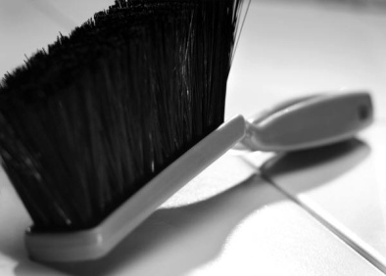
- Scrubbing brush
- Sink brush
- Silk brush
- Toilet brush
- Wall brush
- Soft broom
- Hand brush.
Not all types will be required on all trolleys. It will depend on the facilities to be cleaned, and what exists elsewhere in the property for staff to use such as brushes or brooms available in-room.
All trolleys should have a dust pan and brush set.
- http://clickclack.com/bw/index.asp
- http://www.ravibrush.com/Australia-Range.html.
Buckets
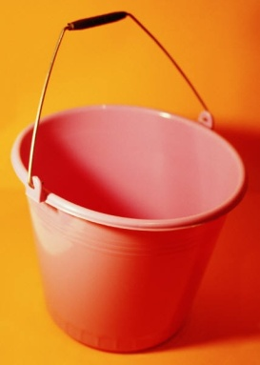
These should be fully operational, not leaking, easy to operate, and not smelly.
Buckets may be required for wet mopping and most room servicing trolleys will also feature a couple of plastic bucket-type containers used to hold cleaning materials, cloths, chemicals and used to carry items into a guest room.
- http://www.masteraustralia.com.au/ and click on ‘Buckets’ in the left-hand side ‘Browse Catalogue’. This site can be used to look at many of the housekeeping mentioned in these notes. It is worth bookmarking for future reference.
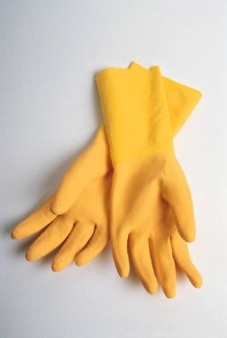
Protective gloves
A good supply of disposable gloves should be on each trolley. Specific house requirements in relation to individual Occupational Safety and Health (OSH) issues may require other, more substantial protective clothing (including gloves) be worn.
It is standard procedure in all premises that room attendants wear protective gloves when cleaning and handling chemicals.
- http://www.masteraustralia.com.au/ and click on ‘Gloves’ in the left-hand side ‘Browse Catalogue’.
Housekeeping uniform
The housekeeping uniform is also regarded as ‘protective clothing’.
- http://www.wst.tas.gov.au/safety_comply/additional_topics/topic/housekeeping.
Cloths
Used for cleaning, polishing and dusting, every trolley will need to have lots of these. Some are made from material and some are disposable.
- http://www.seton.net.au/templates/cleaning_toiletpaper.cfm.
Warning signs
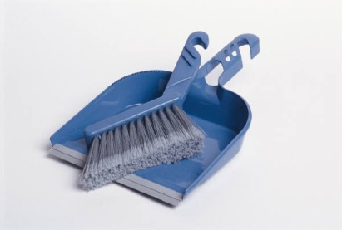
These are safety signs used when a public area is being cleaned as part of the overall room preparation process.
- http://www.hostdirect.com.au/listProduct/Cleaning/ Floor+Signs/.
Dust pan
A dust pan is vital to collect dirt, dust and rubbish.

Cleaning agents and chemicals
Cleaning agents and other chemicals are used to perform various tasks and clean various surfaces.
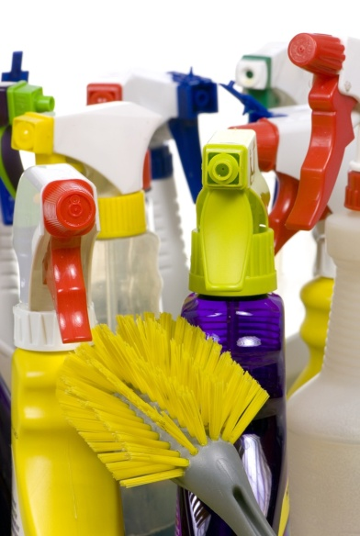
Depending on what is in each room you may be required to have:
- Polishes
- Detergents
- Glass cleaner
- Multi-purpose cleaners
- Oven cleaners
- Stainless steel cleaners
- Leather cleaners
- Porcelain and ceramic cleaners

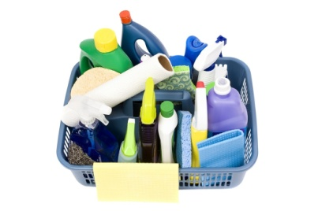
- Toilet and urinal cleaners
- Dishwashing detergent
- Sanitisers
- Disinfectants
- Deodorisers and air sprays
- Pest control sprays and similar.
These products are supplied by industrial chemical companies.
- http://www.shamrockchemicals.com.au/
- http://www.truebluechemicals.com.au/ and click on ‘Housekeeping’.
Some Floor housekeeping stores have their own supply of chemicals while in other instances the supply of chemicals is central (often near the Executive Housekeeper’s office) and you will have to go there to replenish supplies.
Most chemicals in use feature a ‘closed system’ meaning that you don’t need to make physical contact with the chemical. Colour-coding to identify different products plus instructive wall charts assist in selecting and using the right chemical.

Other supplies
Bedding
Clean linen including a range of pillowcases and various sized sheets will be needed to service the sizes of beds that have been allocated.
Trolleys are usually loaded with sheets and pillowcases and other limited supplies of other bed linen are usually stored in the Floor housekeeping store (or central store).
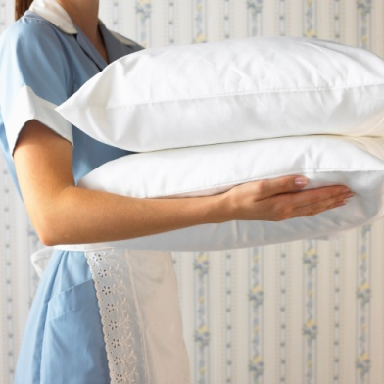
These other items of bed linen again will vary between departments depending on the make-up of the room but could include:
- Pillows
- Pillow protectors
- Blankets
- Doonas, duvets or bedspreads
- Mattress protectors
- Electric blankets.
Toiletries
Towels to replenish items in the bathroom may include supplies of hand towels, face towels, bath towels, and floor mats.
Toiletry giveaways – a wide variety of items are available. Most trolleys will be loaded with one packet of each however there is nearly always a set number of these items that should be placed into each room.
Most house policies, however, allow housekeeping staff to freely provide extras of these items on request by guests.
Items include soaps, shampoos, conditioners, talcum powder, gels, toothpaste, toothbrushes, mouthwash, facial lotions, perfume, aftershave, razors, sewing kits, shoe shine kits.
Stationery
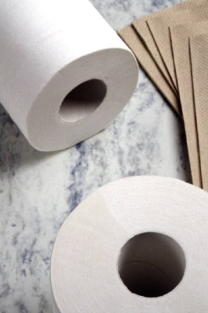
Stationery needs for the in-room compendium or for placement elsewhere in the room such as bedside table or near the telephone. These can include pen, paper, envelopes, forms, notebooks or fax sheets.
Paper products
Paper products include any items that need to be replaced in the guest room.
The nature and type of these items can be expected to change with the style and standard of the property. Examples of these include toilet paper, tissues, sanitary bag and toilet hygiene strip.
Promotional & Informational Material
Advertising, promotional and service-related material including doorknob cards (‘Do Not Disturb – Please Make Up My Room’ cards), service directories, tent cards, magazines, television program guides, sample menus from in-house dining outlets, promotional flyers, as well as room service menus either in the traditional menu format or as a doorknob hangar (for breakfast orders).
Bags
Guest laundry and dry-cleaning bags and lists are to be placed in the room. These bags may be collected on a periodic or on-going basis throughout the shift by porters who take them to the laundry for sorting and washing.
Rubbish bag for stowing rubbish collected from guest rooms and other public areas. This may be ‘built into’ the trolley.
Linen bags whether cloth or calico bag, for placing used linen from guest rooms into. This may be ‘built into’ the trolley.

Give away items
Give-away portion-controlled food items such as coffee, tea, sugars, sugar substitutes, biscuits or milk.
Where the room features a kitchen, the trolley may contain extra food items but such items are usually serviced by room service staff, porters or some other department rather than housekeeping staff. Check with your supervisor to see what applies where you work if you are preparing a room that has a kitchen.
Replacement items
Batteries to replace worn or stolen batteries in remote control units.
Light globes to replace blown globes in, for example, bedside lamps.
Most properties will get the Maintenance department (or porters) to replace any globes or starters that are in ceiling light fittings.

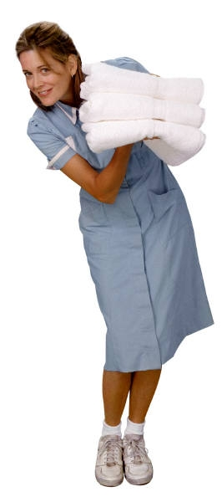
Ordering and receiving supplies
Linen stores and housekeeping trolleys can be stocked at the beginning or end of each shift, but it is preferable that they are fully re-stocked at the end of the day’s work, so they are prepared for the next shift, and so that missing items are able to be bought in before the next shift.
When supplies in the floor housekeeping store room run low, further supplies can be brought up from the housekeeping department where there is usually some form of central store purely for housekeeping supplies.
When requesting supplies you may be required to complete a requisition form.
Requisition form
The requisition form is an internal stock ordering form that you fill in and give to the Head Housekeeper (or other nominated person).
It will identify:
- Person requesting the items
- Type of items needed
- Quantity
- Date.
The majority of housekeeping departments will have a standard order or requisition form.
Requisition forms that are completed and forwarded to the Head Housekeeper at the end of shift today, should result in the supplies that have been ordered (or ‘requisitioned’) being supplied to the appropriate floor housekeeping store room later that day or early the next day before the next shift starts work.

2.2 Load housekeeping trolley with supplies for service

Introduction
In the last section we identified all items that need to be replenished. Depending on the organisation these items will be placed in the linen store or loaded directly onto the housekeeping trolley.
Therefore this section will look at health and safety issues to be addressed when loading housekeeping trolleys.
Occupational safety and health is an on-going concern in all properties, especially in the housekeeping area.
Manual handling activities are the main cause of injuries in the workplace and the housekeeping department traditionally gives rise to the majority of OSH injuries.

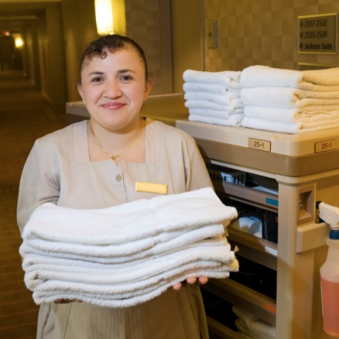
What is manual handling?
Manual handling activities include:
- Lifting – of stock, cartons and boxes
- Carrying – items from storage areas to trolleys, moving stock from place-to-place
- Pulling – boxes and cartons forward in storage areas
- Pushing trolleys.
You have an obligation to safeguard your own safety and welfare, to follow safety procedures and to use safety equipment that is provided when directed to do so.
Your initial on-site training should make you aware of the safety aspects that relate to your role. The employer has a legal obligation to provide this training and to monitor your activities to ensure you are working safely.

Loading trolleys
When loading the trolley, ensure it is loaded safely and does not prevent any danger to others.
Remember that all items should be positioned on the trolley so they won’t fall over or fall off: in addition, nothing should protrude.
If more supplies are needed than the trolley can hold, you will have to refill the trolley during the shift by returning to the floor storeroom: trolleys should never be overloaded.
It is standard industry practice that no ‘extra’ bags are hung off housekeeping trolleys.

Key points to remember when stocking or handling trolleys:
- When identified, immediately report any damage or faults with the trolley – all housekeeping departments should have periodical checks done on equipment by Maintenance department
- Always push the trolley, don’t pull it - it is important for you to see where you are going
- Always stock items in their designated place on the trolley - it is best to position heavy items on the bottom to prevent the trolley from overturning. If you are not sure where things go, ask!
- Never lift anything on your own that weighs over 16 kg – this is a recommendation from OSH authorities. There are no maximum weight restrictions as the current approach is to assess every lifting need on an individual basis and use the most appropriate technique depending on the type of load, how far it has to be moved or the size of the load
- Be prepared to ask for help when needed – this may be a request for help such as to do a ‘team lift’ or a request for information. You must also be prepared to provide help when required.
Trolleys are large items and when fully loaded can be extremely heavy.
The primary concern when handling trolleys is to ensure the safety of the room attendant.
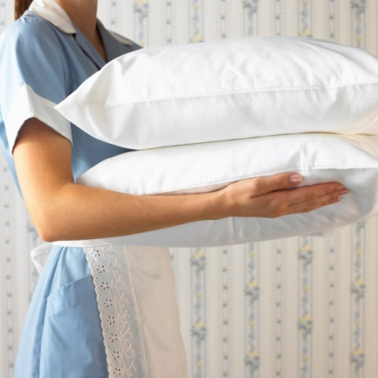

2.3 Check housekeeping trolley prior to use

Introduction
Before leaving the housekeeping office or linen store it is vital that you have all the necessary supplies on your housekeeping trolley.
It is always advised to do a last check to ensure you have everything you need.

Additional items
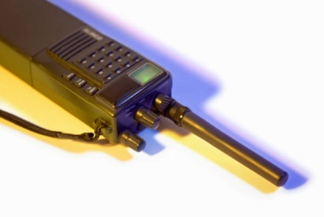
Besides the supplies identified in this manual to date, there are a couple of other items that you may need to take with you:
- Keys for floors and rooms
- Communication walkie-talkie
- List of rooms to clean and alternate rooms if allocated rooms are unavailable for cleaning at that time
- Personal drink container.
In the last section we discussed the importance of manual handling when dealing with trolleys. In this section we will look at security and safety of both staff and customers.

Security of housekeeping trolleys and supplies
Trolleys contain many valuable items and care must be taken to ensure these items are not stolen. Normally when a room attendant is working in the room or bathroom, with the trolley remaining in the corridor, it is often out of view of the room attendant. This means that items can easily be taken by anyone walking by, if the trolley is not securely locked.
It is vital that the security measures used in each organisation are adhered to. Use a lock if one exists. This means room attendants must carefully consider and take the necessary items from the trolley required to service the room as having to regularly unlock trolleys can take up valuable time. By careful selection, time can be saved through efficient movement and reduced time required to go back and forth from the trolley.
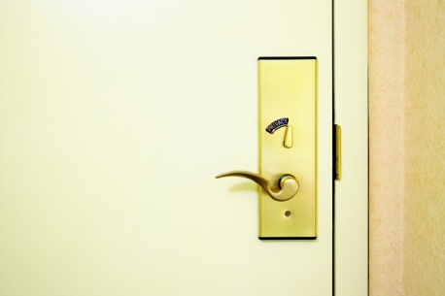
Naturally the theft of keys poses an immediate threat as it allows immediate access to rooms; however room lists contain valuable information including room numbers and names, which could be used by potential thieves who can impersonate guests with this information.

Position of trolleys on guest floors
When on the guest floors the location of where to place the housekeeping trolley is also vital. Security and safety or both customers and room attendants must be considered.
Always position the trolley near the wall and out of the guest’s way. Don’t leave them in the middle of the corridor as:
- It makes it harder for movement of people in the corridor
- It makes it more appealing for theft
- It helps avoid injuries by people bumping into them. This is especially true for children who often run in corridors and at times may not be concentrating on where they are going
- In the event of an emergency including fire where smoke reduces visibility, it is important that corridors remain clear.
So where do you place the trolley?
The trolley will normally be parked across the guest’s door to prevent any unauthorised person accessing the room. This procedure will depend on house policies and procedures.
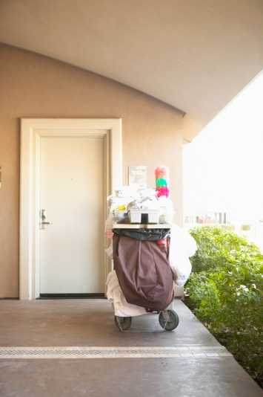
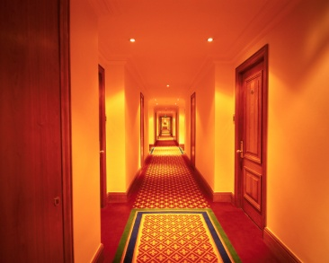

2.4 Identify rooms to be cleaned for the shift

Introduction
In order to service rooms in a timely fashion and to control labour costs, every property will allocate specific rooms to individual staff for room preparation duties.
You may be regularly involved in preparing rooms on the same floor or floors, or you may be required to prepare any rooms in the establishment as occupancy levels dictate and as required on the basis of things such as staff absenteeism.
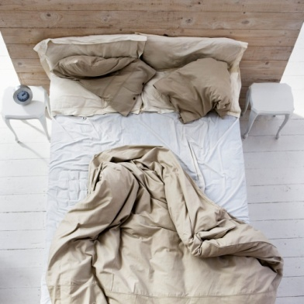
The primary role of a room attendant is to clean rooms.
Most room attendants are required to clean approximately 12-20 rooms a day depending on:
- Organisation standards
- Types of rooms
- Status of the room
- Other considerations.
These points will be discussed in more detail in this section.

Housekeeping briefing session
At the beginning of each shift, most housekeeping departments will hold a short staff briefing session.
This session is an opportunity for the Head Housekeeper to:
- Verify the staff who have attended for work
- Discuss up-coming information that is of relevance – such as future occupancy levels for certain dates, special events, Very Important People (VIPs) who are expected
- Address room servicing problems – by discussing the results of room inspections undertaken by Floor Housekeepers or Head Housekeepers that have identified instances of sub-standard cleaning
- The discussion will identify what the problem was, re-state what the standards are and remind staff of what needs to be done to achieve the required standard
- Address complaints received by guests in relation to the preparation of their rooms – this can include complaints about poor cleaning, lack of supplies or equipment that are not working properly
- Identify up-coming training sessions and known staff absences
- Allocate rooms to individual staff for the shift – this usually takes the form a print-out of rooms that indicates (sometimes by name, sometimes by colour-coded highlighter) which staff are responsible for which rooms.

These print-outs are either generated by Reception as a Housekeeper’s Report, or generated by the Head Housekeeper on the basis of information provided by Reception that indicates the rooms where guests are leaving and the rooms where they are staying.
- Every room attendant receives their own print-out
- It is not standard practice to be verbally informed of the rooms they are required to clean.
The briefing session is also an opportunity for housekeeping staff to raise any issues they have relating to their role, problems they are encountering, things they have identified that could impact on guest service delivery etc.

Organisational standards
Each organisation will have their own expectations on how long it will take to clean a room. This is commonly based on the following points, but also takes into consideration the actual cleaning activities to be performed.

Types of rooms
Generally it is ‘guest rooms’ that will need to be prepared. These rooms can include:
- Single rooms
- Doubles
- Twins
- Suites.
These rooms can contain their own spaces that require servicing such as:
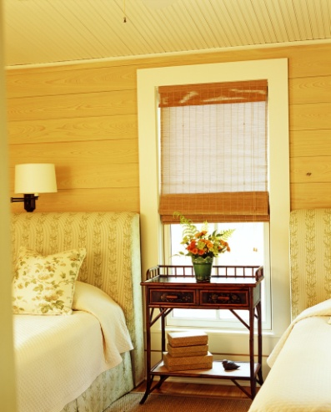
- Bathroom
- Bedroom
- Lounge/living area
- Kitchen/kitchenette
- Balcony area
- Lobby or vestibule.

Status of room
The Head Housekeeper (known also as the Executive Housekeeper) or their appointed associate generally distributes the list of rooms to be cleaned.
There are usually two types of rooms that need to be cleaned:
Check out rooms
These are the rooms where guests are expected to check-out. They may be known as ‘departing rooms’, ‘going rooms’ or ‘vacated rooms’.
These rooms will take longer to clean than a room that continues to be occupied because a full service is required. Approximately thirty minutes is allocated.
The actual time required will depend on:
- The size of the room
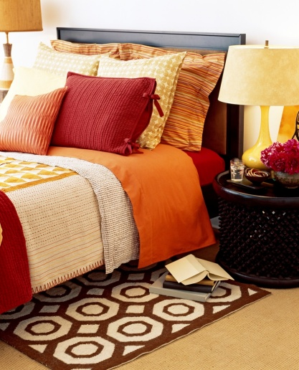
- The furniture, features and facilities in the room
- The condition the room has been left in by the departing guests
- The standards that the property has relating to room preparation.
Occupied rooms
These are rooms where the guest will be staying for another night. They may also be known as ‘stay rooms’.
Generally these rooms won’t take as long to clean as a check-out room, and approximately twenty minutes will be allocated.
Vacant rooms
You will also be required to inspect and provide basic service to vacant rooms.
Vacant rooms are rooms that are not being used and which have been prepared ready for sale by Reception.
These rooms, even though not being used, still require some attention such as:
- Inspection – to identify anything that might have happened or gone wrong with or in the room
- General dusting
- Flushing of the toilet
- Checking that the refrigerator is working properly
- Ensuring the room has not been occupied by a guest for whom no information exists.

Other considerations

When your rooms are allocated to you may also be advised in relation to:
- Which rooms need to be cleaned first – some rooms may have had a special request from a staying guest to have their room serviced quickly or by a certain time
- Special cleaning tasks or stain removal tasks for certain rooms – based on yesterday’s inspection of the room by the Executive Housekeeper
- Time constraints that apply – there is nearly always pressure on room attendants not just to do their job and do it properly but also to do it quickly or as fast as possible
- Other areas in the venue that need to be cleaned – such as public areas, offices.
It is vital for you to follow your allocated room list/work schedule precisely, or rooms that need to be cleaned may be missed and timelines that need to be met may be missed.

Identifying the rooms to be serviced
Which rooms are cleaned first?
You need to check with your employer for their preferences in this regard but the general rule is that the departing rooms are cleaned before the stay rooms.
This is to allow the check-out rooms to be placed back on the board by Reception for sale to guests and to enable guests with bookings to be shown directly to their rooms rather than have them wait while the room is readied, or be re-roomed.
You can be contacted during your shift and asked to clean a specific room immediately as the guest is waiting at Reception for their room.
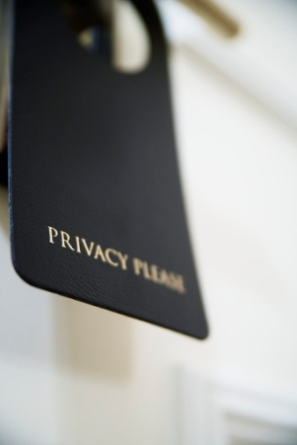
You can be contacted during your shift and asked to attend a certain room and perform supplementary cleaning duties. These may be required because the initial room preparation was not up to standard or because there has been an accident or spillage in the room that requires immediate attention.
You must always respect ‘Do Not Disturb’ (DND) signs. Where a ‘Do Not Disturb’ sign has been displayed on a room throughout your entire shift you must notify the Head Housekeeper of this so they can take the appropriate action.
There may not be a problem, but a check may be made to ensure that the guest is not ill.
‘Please Make Up My Room’ signs can provide some guidance as to what rooms can be cleaned. It is standard procedure to clean these stay rooms before trying to clean stay rooms that do not display this sign.
You should monitor use of rooms that are shown on your list as ’Vacant’. If you see guests using these rooms then the relevant internal procedures must be followed.
These may include notifying the Floor Housekeeper or head Housekeeper, notifying Reception or notifying Security.
It is not your job to challenge guests who are using these rooms. Not only is this rude as the person could be a legitimate walk-in guest who has just been checked in and roomed, but it may jeopardise your personal safety.
You may be required to check guest numbers in occupied rooms – for example, you may be required to advise Reception or Housekeeping if a room designated as ‘S’’ (single appears to be occupied by two or more people).

2.5 Access and enter guest room appropriately

Introduction
All guest rooms must only be accessed after following the house procedures that apply.
These procedures relate to service delivery and security.
They also function to help avoid embarrassment to both guests and staff.

Keys and cards
Keys or cards (using magnetic-strip or RFID technology) are commonly used to access guest rooms. RFID means Radio Frequency Identification Device. It is used to identify information on a hotel room key card. The RFID device (in the door) serves the same purpose as a bar code or a magnetic strip on the back of a credit card or ATM card. It provides a unique code for that object. And, just as a bar code or magnetic strip must be scanned to get the information, the RFID device must be scanned to retrieve the identifying information.
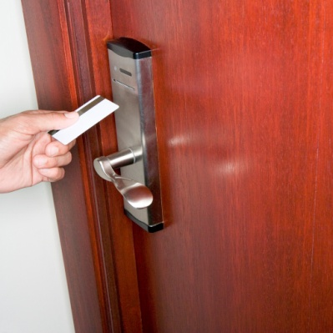
Keys or cards can be produced to open one or more doors. For the purpose of this manual the term ‘key’ will refer to either a key or card.
Commonly the following are produced:
- Guest key– provides access to guest’s rooms and some restricted public areas
- Floor master key– opens every door on a particular floor or in a particular corridor
- Department-specific master – opens every door in the housekeeping area
- Venue master – opens every door in the property.
Room attendants usually receive a Floor master key. Where cards are used they may be issued with a wristband instead of a card.

Security
After the room attendant has signed for their keys, they are responsible for their security until returned to the housekeeping department, and signed back in. The room attendant should never let the key out of their sight.
The key must never be lent to another room attendant, employee or guest without the correct official authorisation.
Keys should never leave the premises.
Keys must never be used to let a guest into their room. This is one of the oldest tricks used by thieves! “Oh dear, I’ve forgotten my key. Would you please let me in to my room?”

Accessing rooms
Every establishment will have its own standard procedures for accessing and entering a guest room. Even if these are not provided in writing, they will nonetheless exist in practice. You must find out what applies where you work and adhere to their protocols.
The process for entering a room listed on your work sheet as a Vacant room or a Departed room should be the same as for entering a Stay room. Just in case someone is in the room: we don’t want to disturb or embarrass anyone in any room just be entering without notice or entering with almost no notice.

Standard procedure to access rooms
The following describes the procedures for entering a guest room:
- Knock on door (quite loudly) – use knuckles not keys or any other item as it could mark the door and call out, “Housekeeping!”
- Count to five
- If no answer, knock again, and then use your key to enter
- Take one step into the room and announce out “Good morning/afternoon, Housekeeping to service your room.”
- If the guest is still in bed, undressed or distressed, quickly and quietly leave the room
- If the guest is awake and up, say “Housekeeping, would you like your room serviced?”
- Comply with their request – you may be invited to service the room, just do a quick tidy, replace the towels, soap and leave, or asked to come back at a later time
- Once you have gained access to the room, the door should be left wide open – to provide notice to a returning guest that someone is in their room
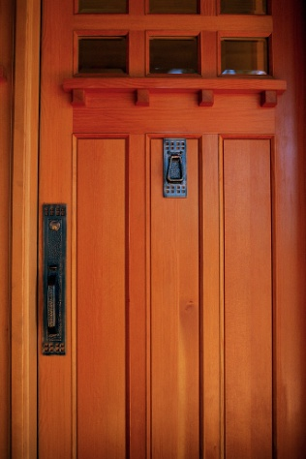
- The trolley should be parked across the entrance, or near the entrance to the room (according to house policy). This allows the Floor Housekeeper or other management staff to identify where room attendants are and makes it easier to obtain items from the trolley
- It is standard procedure in the majority of establishments for trolleys to be left outside the room being cleaned, and never to be taken inside a guest room
- Where the trolley is allowed to be taken into the room, a large sign should be placed outside the door, reading ‘Cleaning in Progress’. This prevents the guest from returning to their room and being startled to find an employee in there and again to enable easy location of staff by management.

Work Projects
It is a requirement of this Unit you complete Work Projects as advised by your Trainer. You must submit documentation, suitable evidence or other relevant proof of completion of the project to your Trainer by the agreed date.
2.1 To fulfil the requirements of this Work Project you are asked to research and identify:
- Supplies used by a room attendant
- Where these supplies are stored and accessed
- What to check on a housekeeping trolley prior to use
2.2 To fulfil the requirements of this Work Project you are asked to research and identify how rooms are allocated on a daily basis to room attendants including explanation of the following for a specific hotel:
- Organisational standards
- Types of rooms
- Status of room
2.3 To fulfil the requirements of this Work Project you are asked to submit evidence of you:
- Correctly accessing and entering a guest room

Summary

Prepare for cleaning duties
Replenish linen room supplies
- Need for adequate supplies
- Equipment
- Cleaning agents and chemicals
- Other supplies
- Ordering and receiving supplies.
Load housekeeping trolley with supplies for service
- What is manual handling?
- Loading trolleys.
Check housekeeping trolley prior to use
- Additional items
- Security of housekeeping trolleys and supplies
- Position of trolleys on guest floors.
Identify rooms to be cleaned for the shift
- Housekeeping briefing session
- Organisational standards
- Types of rooms
- Status of room
- Other considerations
- Identifying the rooms to be serviced.
Access and enter guest room appropriately
- Keys and cards
- Security
- Accessing rooms
- Standard procedure to access rooms.

Element 3:
Make beds

3.1 Strip and re-make bed with fresh bed linen

Introduction
Once you have successfully entered the room, it is now time to start cleaning the room.
Usually one of the first tasks is to make the beds.
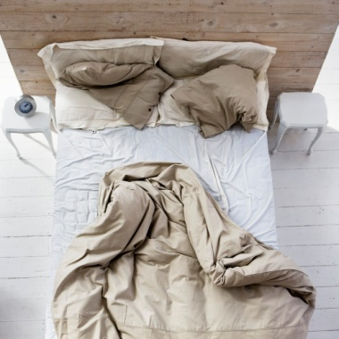
Beds will need to be stripped in all departing rooms and at nominated intervals for staying guests.
Standard procedures for this process will apply in every establishment as this is one of the most common tasks that room attendants are required to perform.
Bed making tasks give rise to many injuries to staff and some properties use two room attendants to service each room so that, amongst other things, bed-making tasks can be completed with less chance of injury.

When should the bed be stripped?
House policy will dictate what applies and there is usually a connection between the service provided and the room rate being charged.
Options include:
- Daily – in high-priced rooms, prestige establishments: full change
- Every second or third day – full change
- Change when the condition of the linen requires it – such as situations where linen is dirty or damaged.
Some properties will replace nothing if the guest is a short stay – which may be defined as three nights or less. In this case, a guest who is known to be checking out after three days may not have their bed linen changed even though standard practice is to change bed linen every two days.
Some properties use fitted bottom sheets but where they are not used, you may be required every day or second day to remove the bottom sheet, use the top sheet as the bottom sheet and fit a fresh top sheet.

Stripping a bed
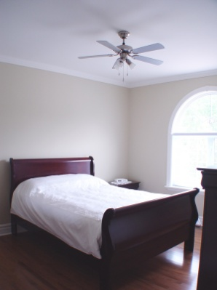
The room attendant should follow house procedures to strip a bed. These can be individual to the property depending on whether one or two staff are being used, and what linen is involved.
The following is a representative guide of what is involved:
1. Remove bedspread or duvet. – inspect and air, or replace as required. All bedspreads etc are washed or dry-cleaned periodically
2. Remove blankets (where provided) - inspect and air, or replace as required. All blankets are washed or dry-cleaned periodically
3. Remove pillowcases – place into soiled linen bag. Inspect pillow and pillow protectors to determine if they require attention or replacement
4. Remove sheets - place into soiled linen bag
5. Check mattress protector – spot clean as necessary or replace if required due to staining or damage
6. Inspect electric blanket – safety check and for signs of staining. Replace as per house protocols.
Items that have been stripped from the bed should not be placed on the floor. Check what applies in your establishment but options include placing them on chairs, tables, couches in the room.
Not only does it look bad for guests to see these items on the floor if they enter the room while you are cleaning it, or they walk past the door on the and look in) but it is also unhygienic.

Damaged or soiled bed items
When damaged items are found they must be replaced, with the damaged item either forwarded to the appropriate department for repair or by notifying the appropriate person so that they can pick it up.
If damage appears intentional contact your supervisor so that a decision can be made about charging the guest for the damage.
Where what appears to be deliberate soiling of items has occurred, the same procedure applies. A similar arrangement may also apply where ‘excess’ mess is left by guests.
There are many approaches taken by different establishments to the removal of stains in guest rooms.
Some properties will require you to remove the stained item replace it and forward it to the Laundry or some other nominated department for their attention
Some venues will ask you to identify what the stain is and follow their established guidelines for stain removal.
Other establishments will ask you to involve the Head Housekeeper and obtain their advice about what to do.

Types of stains

Common stains found on carpets, mattresses, bed linen and chairs and couches made with fabric are:
- Urine and faeces
- Blood
- Beverage – tea, soft drinks, alcohol of all types
- Shoe polish
- Food
- Mud, dirt, grease and oil.
What action may be taken?
The first step is to develop the ability to identify the stain. Trial and error coupled with some coaching from experienced staff are the keys to this.
You cannot expect to effectively treat a stain unless you have correctly identified what has caused the stain.
In most cases a stain will require bed linen to be exchanged for fresh items. There are virtually no occasions when spot-cleaning of these items is appropriate for room attendants.
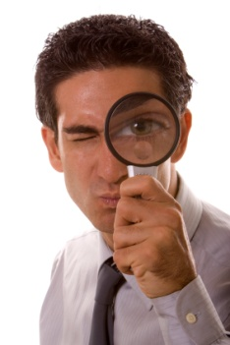
Where spot cleaning appears suitable, the appropriate cleaner from those stocked on the trolley is selected and applied according to manufacturer’s instructions, which can commonly be via a spray bottle applicator, or rubbed directly onto the stain.
The stained area is then rubbed/brushed to remove the stain, rinsed and then dried.
Most establishments will have a chart to guide in the removal of stains. These charts are specific to the chemicals provided by the chemical supplier being used at the property, and will identify which cleaner is to be used for which stain on which fabric or surface, together with how to apply the cleaner, and other relevant tips and information.
Remember that the ‘correct’ action to take when dealing with stains will depend on interaction of:
- The type of material where the stain has occurred
- The cause of the stain
- The chemicals available to remove the stain.
This essentially means that providing generic advice on stain removal is not only impossible, but potentially misleading as it can prove dangerous, damaging and expensive.

You need to know to the best extent possible:
- What the material or surface is that has been stained
- What the stain is
- What chemical options you have for treatment.
Check out the following sites for further details and contact your industrial chemical supplier for more exact information that may apply to your workplace:
- http://www.hospitalitynet.org/news/154000320/4026910.search?query=hotel%20
- http://findarticles.com/p/articles/mi_m3072/is_7_220/ai_n15699154
- http://housekeeping.about.com/od/stainremoval/a/inkstains.htm
- http://www.goodhousekeeping.com/home/stain-buster/.

Remaking bed with fresh linen
As with stripping of beds, individual properties have their own standards, procedures and requirements for making beds.
Making beds is a common activity that needs to be practiced and undertaken with great care as many injuries have resulted from moving the bed in order to make it.

The importance of bed making
Making the bed ‘properly’ is an extremely important part of servicing any room because the bed is often the focal point of the room and one of the first things in the room that the guest looks at.
The final appearance of the made bed must therefore make the right impression – neat, tidy, balanced, crisp, clean, attractive and inviting.
Special points in relation to final presentation of the bed can include:
- The use of an overlay placed across the end of the bed to enhance eye appeal
- Number of pillows provided – standard procedure may be to place only one pillow per person on the bed with additional pillows available in the wardrobe of the room for guests to help themselves to: in a stay room, if the guest has used two pillows per person then the bed should be re-made following their preference
- Use of decorator pillows – to enhance presentation
- Placement of the pillows – the property may lie the pillows down, stand them up or arrange them in some unique way
- Number of blankets used – most properties use one blanket on a bed with extra blankets available in the wardrobe or on request
- Placement of a complimentary item on the bed – this may be done as part of the turn-down procedures but may also be a standing requirement when servicing the room.

Bed making styles
Your workplace may have its own bed making style but there are three styles of bed making commonly used in the hospitality industry:
Standard style
This uses:
- Mattress protector
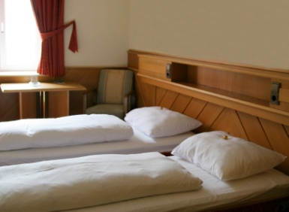
- Bottom sheet
- Top sheet
- Blanket
- Bedspread
- Pillows
- Pillowcases.
American style
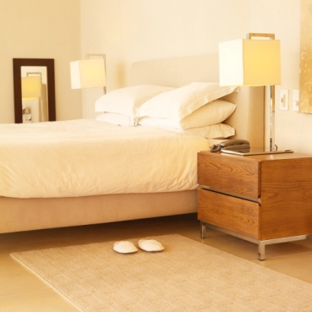
This features:
- Mattress protector
- Bottom sheet
- Top sheet
- Bedspread
- Pillows
- Pillowcases.
Norwegian style
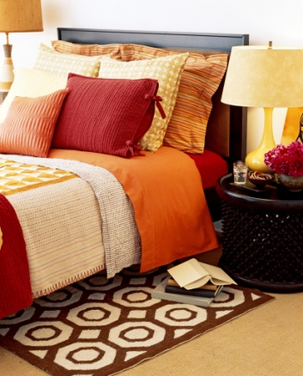
This uses:
- Mattress protector
- Bottom sheet
- Quilt
- Quilt protector
- Quilt cover
- Pillows
- Pillowcases.
Electric blankets are used in some hotels and where they are fitted, the electric blanket security straps must be checked to ensure the blanket is straight and in place.

Bed making steps
Use the following steps as a guideline for making a standard style bed where no house requirements apply:
1. Check electric blanket is straight and secured
2. Position mattress protector and secure strings
3. With seams down, position bottom sheet
4. Mitre bottom sheet – all four corners by:
- Tucking cover along foot and head of mattress
- Lifting corner flap – about 30cm from corner
- Tucking in remaining portion of cover
- Dropping flap and tucking in
5. Smooth out creases
6. With seams up, position top sheet – top edge even with mattress at bed head
7. Position blanket – seams up
8. Turn head of top sheet over blanket
9. Smooth out creases
10. Tuck in top sheet and blanket on sides
11. Mitre all corners, top sheet and blanket together
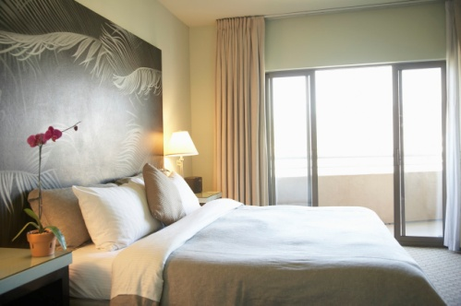
12. Smooth out creases
13. Position bedspread so it is straight and all corners are even
14. Fold back bedspread at bed head end
15. Place pillowcases on fluffed up pillows
16. Position pillows on the bed as required
17. Fold bedspread over pillow and neatly tuck in.
Points to remember
- Make sure all the fresh linen to go onto the bed is placed onto a chair, table or couch while you are making the bed – it must never be left on the floor
- When you have finished making the bed, step back and inspect it to make sure it is right:, then adjust as required
- The way you make your bed at home is probably not going to be what is required at work
- The way you made beds at your last employer is probably not going to be the same as what is required with your current employer.

More information
Your in-house procedures must be your primary resource but where they don’t exist and the above is unacceptable, take a look at the following sites for guidance and inspiration:
- http://www.wikihow.com/Make-up-a-Bed-Neatly
- http://www.tutorials.com/06/0630/0630.asp
- http://housekeeping.about.com/od/bedrooms/ht/makebed.htm
- http://www.foodfunandfacts.com/bedmaking.htm
- http://www.ehow.com/how_2049032_fold-hospital-corner.html.

3.2 Re-make bed using existing bed linen

Introduction
Section 3.1 provided detailed instruction in how to make strip and make a bed. If a guest has departed the room, it is vital that fresh bedding is used. But what if it is an ‘occupied’ room where the guest is staying for more than one day?
Depending on the type of organisation you are, and the level of service provided, it is becoming more common for bedding not to be changed on a daily basis. As environmental awareness increases, many hotel managers and customers alike, do not feel the need for sheets to be changed on a daily basis. However this cannot always be assumed. Therefore many hotels have ‘Request Cards’ which allow the guest to decide if they require their bedding to be changed. These cards are commonly found in hotel rooms throughout the world.
Simply, guests place this card on the bed, which identifies that the guest would like their bed linen changed. If this card is not placed on the bed, the existing bed linen will be used.
This practice has a number of benefits:
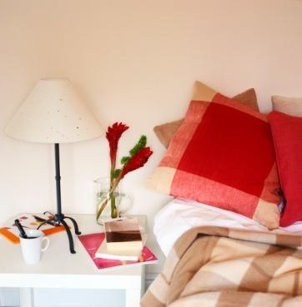
- It is environmentally friendly – as less washing is required
- It reduces expenses for a hotel.
Most guests do not expect their linen to be changed every day, unless it requires it due to stains or damage. It is standard practice for most venues to change linen after 3 days.
So what do we do differently when making the bed for an occupied room as opposed to a departure room?

Remaking a bed using existing bed linen
Whilst the instructions may reflect those previously given in Section 3.1, it is important that clear procedures are identified when making a bed for an occupied room.
1. Remove pillows and place them on a clean surface, checking for stains or need for replacement
2. Remove or pull back any blankets or duvets, again checking for stains or need for replacement
3. Straighten bottom sheet, again checking for stains or need for replacement. If a new sheet is required, change accordingly
4. Re-tuck in sheet
5. Smooth out creases
6. With seams up, position top sheet – top edge even with mattress at bed head
7. Position blanket – seams up
8. Turn head of top sheet over blanket
9. Smooth out creases
10. Tuck in top sheet and blanket on sides
11. Mitre all corners, top sheet and blanket together
12. Smooth out creases
13. Position bedspread so it is straight and all corners are even
14. Fold back bedspread at bed head end
15. Place pillowcases on fluffed up pillows
16. Position pillows on the bed as required
17. Fold bedspread over pillow and neatly tuck in.
Points to remember
Take special note of the preferences of the guest. Before making the bed check to identify preferences including:
- If they have removed the blanket or duvet, you may wish to place this in the cupboard or folded back at the end of the bed
- If they have more pillows, make the bed and position the pillows accordingly
- If items such as books, magazines, glasses, clothes or other personal items were found on the bed, place them neatly back on the bed in a similar position.
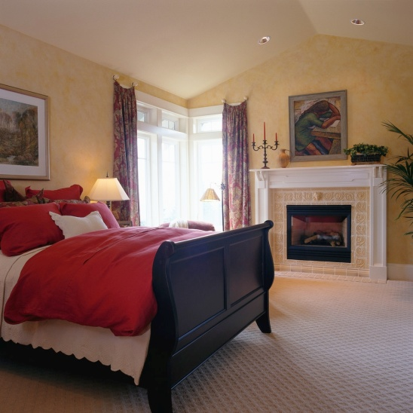
Work Projects
It is a requirement of this Unit you complete Work Projects as advised by your Trainer. You must submit documentation, suitable evidence or other relevant proof of completion of the project to your Trainer by the agreed date.
3.1 To fulfil the requirements of this Work Project you are asked to submit evidence of you making a bed with fresh bed linen:
- Correctly stripping a bed
- Selecting correct bed linen
- Making a bed with fresh bed linen
3.2 To fulfil the requirements of this Work Project you are asked to submit evidence of you making a bed using existing bed linen:
- Correctly stripping a bed
- Checking for bed linen needing replacement due to spoiling or damage
- Making a bed with existing bed linen
- Placing guest personal items in an appropriate location

Summary

Make beds
Strip and re-make bed with fresh bed linen
- When should the bed be stripped?
- Stripping a bed
- Damaged or soiled bed items
- Remaking bed with fresh linen
- Bed making styles
- Bed making steps.
Remake bed using existing bed linen
- Remaking a bed using existing bed linen.

Element 4:
Clean bathroom

4.1 Clean bath and shower area

Servicing the bathroom
Before a bathroom can be cleaned it, too, must be prepared.
The following steps should be taken to prepare a bathroom for cleaning:
- Collect all dirty towelling items and place in soiled laundry bag
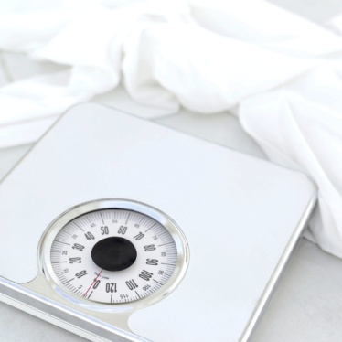
- Collect all used bathroom supplies – shampoo, conditioner and soap
- Check shower curtain for cleanliness – remove if soiled
- Check all light globes
- Check all electrical equipment for damage or faults
- Check all fixtures and fittings for damage or defects.
All damage, faults and defects should be reported to the floor supervisor or the Maintenance department.
Handling syringes
If you find a syringe, the following steps should be taken to remove it safely.

1. Don’t panic.
2. Don’t touch the needle with bare hands and do not attempt to recap it.
3. Find a sturdy plastic container.
4. Ease the syringe into the container without making skin contact with it – where applicable, use a brush and shovel to sweep syringe up.
5. Tightly seal the container.
6. Immediately wash your hands.
7. Immediately alert the appropriate person for correct disposal of syringe.
Check house policies and procedures for the removal of syringes, and follow them where they differ from the above.

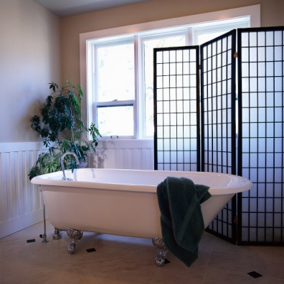
Cleaning the bath
Always wear protective gloves when cleaning a bath.
Take extra care when cleaning baths as this task has been a cause of many workplace injuries for room attendants.
The following applies:
1. Wet tub with water and check plughole for foreign matter
2. Scour tub using non-metal pad – removing stains, residue and marks
3. Clean and polish taps
4. Rinse bath thoroughly
5. Dry and polish with cloth
6. Conduct final inspection.

Cleaning the shower
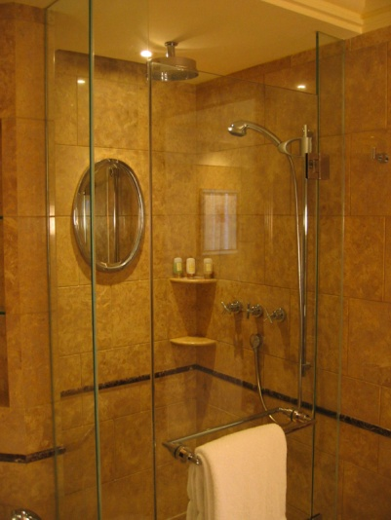
Always wear protective gloves when cleaning a shower.
The shower can be effectively cleaned as follows:
1. Wet shower basin and sides.
2. Clean tiles and floor – check plughole for foreign matter.
3. Clean shower curtain – check pole is clean and all hooks are in place and working.
4. Rinse walls and floor thoroughly.
5. Polish fittings.
6. Replenish supplies – shampoo, conditioner and soap
7. Conduct final inspection – leave shower curtain neat and to one side

4.2 Clean toilets

Introduction
Cleaning the toilet is not the most appealing of jobs, but ensuring it is hygienically clean is vital. A hotel can provide the best of products and services however if the toilet is unclean, all of the best efforts are wasted.
Therefore attention to detail when cleaning toilets is important.
Firstly, it is important to remember to always wear protective gloves when cleaning a toilet.

Steps to clean the toilet
The following steps are effective when:
1. Flush toilet to wet sides of bowl
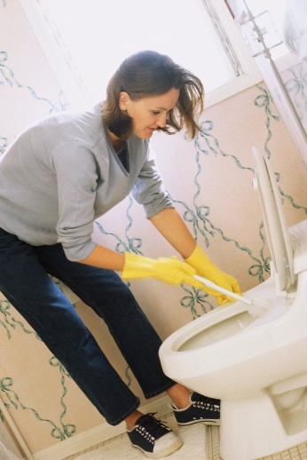
2. Pour in cleanser – leave to soak: continue with other work
3. Wash lid and dry – both sides and near back hinges
4. Wash seat and dry – both sides and near back hinges
5. Wash outsides of the bowl and dry
6. Wash and dry water holding unit and polish button
7. Scour bowl thoroughly – use a toilet brush
8. Flush toilet a number of times to wash away dirt and residue
9. Place a hygiene strip over the closed toilet lid
10. Conduct final inspection – leave lid down when thoroughly cleaned. Add hygiene strip, if appropriate.
It is essential that any evidence of past guests are removed. Take a second to recheck that the toilet is clean. This includes the lid and seats, on both sides.
It is also important to ensure any chemicals are removed from toilet surfaces as this cause discomfort if coming in contact with the skin of guests.

4.3 Clean vanity area

Introduction
The vanity area is normally the most used area in a bathroom and is used for a variety of tasks by guests. Most of their personal bathroom items are stored there.
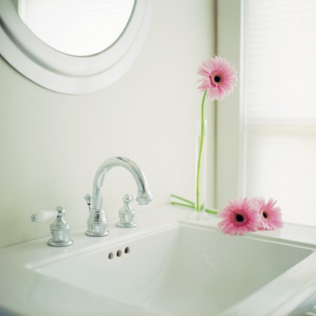
The vanity area normally includes:
- Bathroom bench
- Basins
- Taps
- Mirror
- Cupboards
- Handtowels
- Amenities
- Soap containers.
Cleaning the vanity area in a check-out room is easier than that in an occupied room, because of the presence of the guest’s toiletry items.

Cleaning the vanity area
Always wear protective gloves when cleaning the vanity area.
The recommended steps are:
1. Clean and dry shelves – replacing guest’s toiletries, where applicable
2. Scrub hand basin, rinse, then dry and polish with clean cloth – check plughole
3. Polish fittings and taps
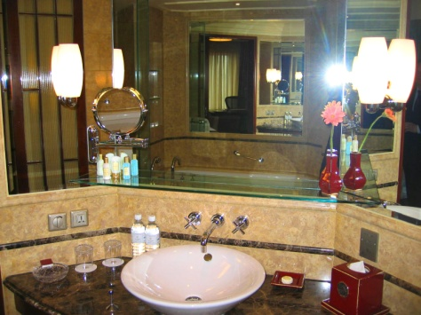
4. Clean and dry wall tiles
5. Clean, dry and polish bench top
6. Clean and polish mirror
7. Check under vanity for cleanliness – cobwebs, etc
8. Replenish stock – soap, tissues, facial items, shower caps, water
9. Replenish towels – bath, face, hand, and floor mats
10. Conduct final check.
Remember to always try to place guest’s personal items where you found them.

4.4 Clean floors

Introduction
Bathroom floors can become very dirty places and therefore it is important they are cleaned correctly and thoroughly.
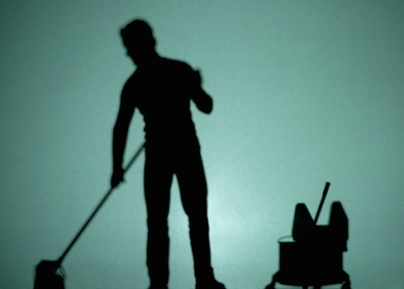
Dirt and dust, hairsprays, soaps and shampoos used within the confines of the bathroom dirt will cause messy floor surfaces. Tiled floors are appealing when they're clean and sparkling, it doesn't take much to sully them. Dirt and grime trapped between the tiles and marring the appearance of the grout can make your entire bathroom feel unclean. Keeping the tiled bathroom floor is essential not only for keeping your bathroom looking good, but for good hygiene reasons as well.

Steps to cleaning bathroom floors
- Remove everything that may be on the bathroom floor such as mats, trash cans, and small pieces of furniture
- Sweep the floor to remove dirt, hair, dust, and other debris
- Dissolve detergent into warm water using the manufacturer's instructions for the correct water to detergent ratio
- Pour the solution over the entire floor so that the solution can fill into the grout lines
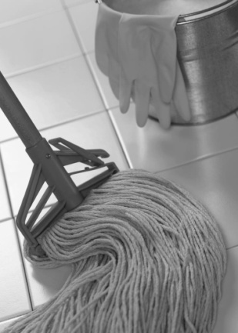
- Allow the solution to remain on the floor for 15 to 20 minutes
- Scrub the grout with a small medium-bristled brush
- Rinse the floor with a mop dampened with clean water
- Mix a second batch of detergent and water
- Mop the entire floor with the fresh solution
- Rinse the mop with clean water and mop a second time over the floor to rinse it
- Use a squeegee to push residual moisture to one area of the floor before absorbing it with dry towels.

4.5 Replenish guest supplies

Replenish guest supplies
It is important that all guest supplies are replenished in the bathroom.
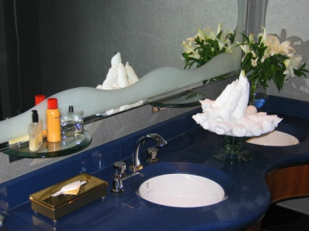
Some of the supplies that are required in a guest room include:
- Toilet paper and sanitary pads and bags
- Tissues
- Towels including hand towels, face cloths, bathmats, bath towels
- Shampoo
- Conditioner
- Moisturiser
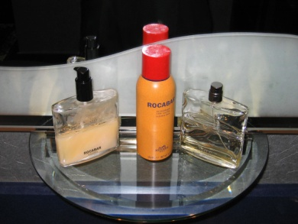
- Hand lotion
- Toothbrushes and toothpaste
- Make up remover
- Combs
- Water
- Soap
- Perfumes, aftershaves and other fragrances
- Sewing kits.
Every organisation will have different supplies that must be included in a bathroom. It is important you know what these are. As on the list above, there can be quite a variety of products.

Final check of bathroom
Before leaving the bathroom, do a final check noting the following points:
- Bathroom looks clean and tidy
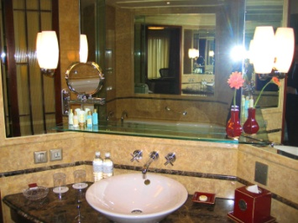
- Towels and guest supplies have been replenished and stocked accordingly
- Toilet paper is well-stocked
- All appliances are working
- All surfaces are clean and dry.

Work Projects
It is a requirement of this Unit you complete Work Projects as advised by your Trainer. You must submit documentation, suitable evidence or other relevant proof of completion of the project to your Trainer by the agreed date.
4.1 To fulfil the requirements of this Work Project you are asked to submit evidence of you cleaning a bathroom including:
- Cleaning bath
- Cleaning shower
- Cleaning vanity area
- Cleaning floors
- Replenishing guest supplies including the identification of all supplies used in the bathroom.

Summary

Clean bathroom
Clean bath and shower area
- Servicing the bathroom
- Cleaning the bath
- Cleaning the shower.
Clean toilets
- Steps to clean the toilet.
Clean vanity area
- Cleaning vanity/washing area.
Clean floors
- Steps to cleaning bathroom floors.
Replenish guest supplies
- Replenish guest supplies
- Final check of bathroom.

Element 5:
Clean room

5.1 Follow in-house requirements and policies in relation to room cleaning

Introduction
Housekeeping has an extensive list of requirements and policies relating to what tasks a room attendant should perform and how they should be performed.
The different sections in this manual will explain in detail the correct steps required in cleaning different aspects of a room, however a ‘correct order’ for cleaning must be determined.

Cleaning in the correct order
All guest rooms that are allocated to you must be cleaned in the correct order.
The ‘correct order’ may be determined as a result of one or more of the following:
- As directed by the Executive Housekeeper
- As requested by guests
- So that vacated rooms can be put back on the (Front Office) board for sale/occupancy as soon as possible.
Factors impacting on the ‘correct order’
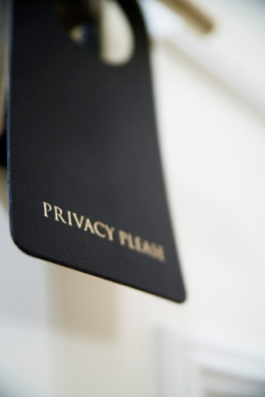
In some cases, room attendants from different floors may be required to go to a nominated floor and combine their efforts to clean rooms on that floor where, for example, a group has just vacated the rooms on that floor and another group is expected in to fill them.
This will delay the cleaning of their allocated rooms on their floors.
In other cases, guests may be late checking out so the ‘going rooms’ may not be able to be cleaned when anticipated.
There will be guests who affect your intended order of cleaning rooms by displaying a ‘Do Not Disturb’ sign on their door.
This highlights that there is never any strict ‘correct order’ because of the fluid and unpredictable nature of the business and the guests who use the accommodation: there may be a preferred order but this rarely translates into what actually happens.

Minimising disruption to guests
When cleaning rooms you must always strive to keep the disruption caused to guests to an absolute minimum.
Cleaning duties can disrupt guests:
- As a result of noise caused during the cleaning activities and when moving about ion the corridors
- By providing a physical obstruction to them when they are moving about the corridors etc
- Through unwanted interruption to their activities in the room when you knock to offer ‘Housekeeping’.
Ways to minimise disruption to guests
When you understand the causes of a problem you are better placed to solve the problem, so practical ways in which to minimise interruptions to guests are:

- Always respect ‘Do Not Disturb’ signs
- Keep noise when moving around the floor to a minimum
- Converse quietly with other staff and guests
- Avoid knocking equipment into things
- Keep trolleys and equipment away from guest traffic areas
- Always allow guests right of way in a corridor or lift.
Remember too that guests do not always keep regular hours. Room guests may have flown in on a late flight and be sleeping in or they may have had a late night.
Other room guests may be using their room for business purposes and not want to be disturbed.
Preparing guest room prior to cleaning
When you have entered the guest room following the steps described in later sections which will provide a guide as to what should take place in order to clean a room.
Remember, where the house procedures are different to the following guidelines, always adhere to your enterprise procedures.

Cleaning a Check-out room
If the guest is still there after check-out time and in the process of leaving, use your discretion about whether to leave and come back later, or whether to excuse yourself and begin cleaning.
In situations where Reception is expecting a quick turn-around of rooms due to full occupancy it may be acceptable to begin cleaning a check-out room while the guest is still there if they have passed the advertised check-out time and no late check-out has been arranged.

In a check-out room the following procedures are applicable:
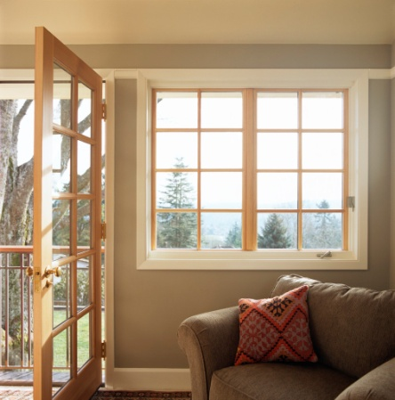
- Turn on all lights and check the bulbs – replace where necessary
- Open all blinds and curtains
- Open windows or doors to let in fresh air – if applicable, and if weather permits
- Turn off fridge for defrosting purposes and leave door open – if applicable
- Collect and remove dirty towels, dishes, bottles and rubbish - any broken glass should be wrapped safely in newspaper or similar
- Remove any room service trays and cover them with a napkin as exposed stale food is not a pleasant sight. These trays are usually placed in the corridor outside the room for collection by the porter or room service staff.

Preparing a room for cleaning
As soon as you have completed the above tasks the cleaning proper can begin. This procedure should be the same for every room.
Following a standard procedure and routine helps to avoid any areas being missed, and is more time effective.
The exact detail of how to complete each of these steps will be detailed through the manual.
Although the exact procedure may vary from establishment to establishment, there are eleven general steps to cleaning any guest room.
Where your premises vary from these, adhere to house policy:
1. Enter and prepare room
2. Strip and make bed
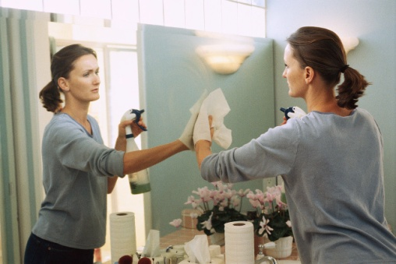
3. Clear and clean bathroom
4. Replenish all bathroom supplies
5. Dust and polish
6. Replenish guest supplies
7. Clean bins
8. Clean fridge
9. Vacuum
10. Deodorise
11. Do a final inspection.

Cleaning an occupied room
Key points to remember when cleaning an occupied room:
- Never throw out any items like magazines and newspapers belonging to the guest, no matter how old they are
- Always replace items where they were found
- If business papers are out on the desk or table and obviously being used, avoid cleaning or tidying that area, apart from emptying the waste paper bin
- Respect the guest’s privacy and don’t be nosy
- Take special care with all guest’s items
- Hang guest’s clothing up appropriately
- All cloths used in cleaning should be housekeeping issued – room towels and linen should never be used for cleaning but check your house practices relating to the use of bath towels for drying bathroom areas.
For detailed information how to perform different tasks by a room attendant when cleaning a room please refer to the appropriate section in this manual.

5.2 Clean fixtures and fittings

Introduction
All rooms will have furniture, fixtures and fittings to some extent.
These relate to all the items in the room that may be used by a guest during their stay.
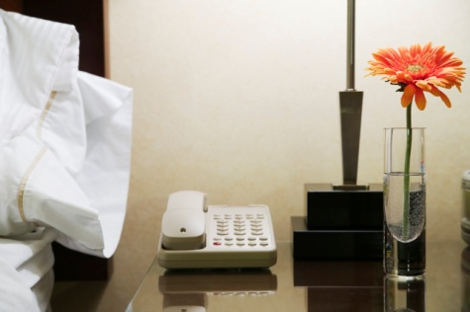
Furniture commonly refers to items in the room that are movable including beds, couches, desks, television, clock radios etc.
Fixtures refer to items that are attached that are used by the guest including air conditioning and light switches.
Fittings refer to taps, pipes and electrical aspects of the room.
This section will explain some methods used to clean fixtures and fittings.

Dusting and polishing
The main purpose of dusting is to collect small particles of dust.
The main purpose of polishing is to clean the item and leave a shiny, reflecting finish.
Dusting may be done with a duster or a damp lint-free cloth.
It is important to use common sense when choosing which piece of equipment to dust with. Don’t use a damp cloth if the moisture could ruin the object being cleaned and remember to change the cloth when soiled.
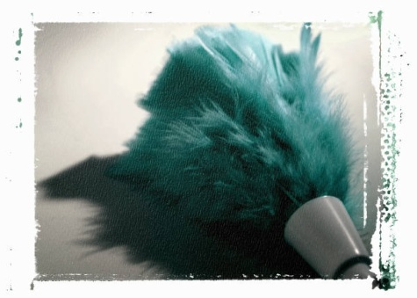
Your on-the-job training, which will probably include being teamed up with an experienced room attendant for a period of time, will provide the workplace guidance you need in this regard.
When polishing an item, make sure to:
- Spray the cleaning agent onto the cloth - not onto the surface to be cleaned
- Buff the surface after cleaning to remove any streaks.
When dusting and polishing a room, it is best to start in one spot and work around the room, say, in a clockwise direction. This routine should be followed in every room. Some small items may need to be picked up in order to dust or polish underneath.
The following areas will need either dusting or polishing. Some will need cleaning on a daily basis, while others may only need to be cleaned weekly.
Remember that check-out rooms will need more intensive cleaning than occupied rooms, however all rooms must be cleaned to establishment standards, including the following:
- Air conditioning vents
- Doors – including top ledge and handles
- Picture frames – facing glass as well as frame
- Mirrors – frame and mirror
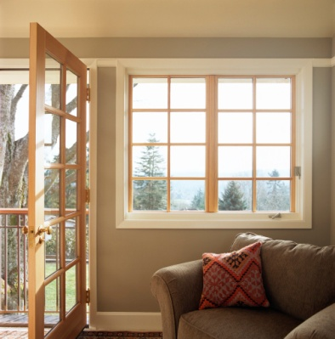
- Skirting boards
- Dressing table and drawers
- Side tables and ledges
- Wardrobe and internal shelving
- Windows – glass and frames
- Window sills
- Walls – check for cobwebs and marks
- Lamps – base, shade and cord
- Telephone – main unit and hand receiver
- Seat furniture – don’t forget to remove cushions and check sides, legs, back and underneath
- All furniture – top, sides, legs, and underneath each item; don’t forget to clean inside the drawers
- Outside/balcony areas – furniture, ash trays.

Cleaning bins
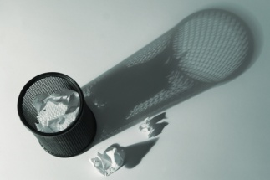
You should always wear protective gloves when cleaning the bin and should be extra careful when handling the bin as many hazardous items may have been thrown out by the guest – such as broken glass, razor blades and syringes.
Always be vigilant for items that could cause any health or safety risk.
Broken glassware or bottles should be wrapped up in newspaper and disposed of separately and safely.
Waste bins should be properly cleaned by:
- Tying the bin liner around the rubbish or emptying the bin directly into your waste bag on the trolley
- Spraying bin with appropriate multi-purpose cleaner, inside and out
- Cleaning with the appropriate cloth
- Fitting a new bin liner in the manner approved by the establishment.

5.3 Vacuum floors and other areas

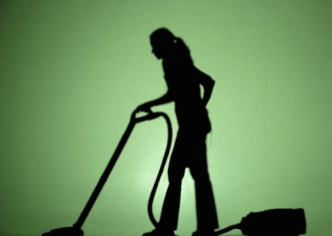
Introduction
All carpeted areas should be vacuumed and many non-carpeted areas including wooden floors, tiled bathroom area, linoleum floors in kitchenette may also require vacuuming.
It is essential that all surfaces are clean and free from dirt, dust and other items.

Vacuuming
Any stains on carpeted areas should be removed using the appropriate stain removal method for your property that relates specifically to the type of carpet, the active ingredients of the chemical and the type of stain. Where this does not remove the stain, a maintenance report may need to be completed or the supervisor notified.
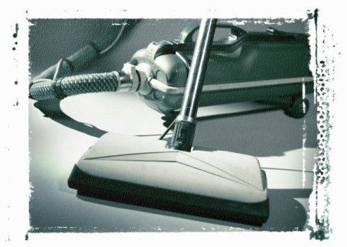
Try to vacuum the room starting at the furthest corner from the door and work back toward the exit.
Ensure you vacuum around and under all furniture, and under the bed.
Particular attention should be given to the corners of the room, including the skirting boards.
To avoid injury when vacuuming, bend your knees when cleaning under items.
Try to avoid ‘bending over’ the machine. Keep it behind you where possible, moving it forward as you vacuum from a point furthest from the room entry door towards the entrance door of the room.

5.4 Clean kitchenette area, where applicable

Introduction
Some venues may have a kitchenette included in the accommodation. This may come in various shapes or forms and have different inclusions.
In apartment and self-catering style accommodation, the products included might be detailed and include:
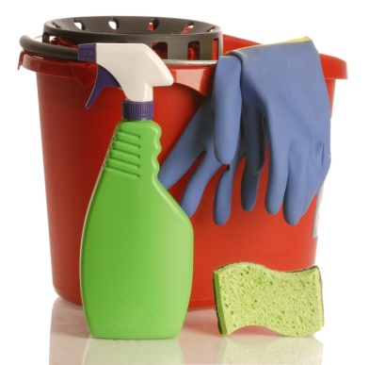
- Refrigerator
- Cook top and oven
- Microwave oven
- Dishwasher
- Tea and coffee making facilities
- Pots and pans
- Crockery and cutlery
- Clothes washer and dryer.
This section will explore the best way to undertake cleaning of some of these items.

Cleaning the refrigerator
All food items left by guests should be handled in accordance with house policy – this may mean returning all unused items left by guests to the housekeeping office. Guests have been known to call and inquire about their food items, which they have wanted to reclaim.
Other policies may allow you to discard any partially used food items that are found in the refrigerator or elsewhere in a check-out room.
The refrigerator is usually cleaned on regular basis (that is, not daily but weekly or other), or on a needs-only basis.
When cleaning the refrigerator you may be required to turn it off, depending on the cleaning procedure to be applied before the cleaning starts.
The recommended procedure is:
- Clean the inside of the refrigerator, including seals, with either hot soapy water or a designated spray-on cleaner. Dry with a cloth when the cleaning has been done
- Make sure food products and glasses are protected from chemical contamination during the cleaning process. Covering them or removing them are the only safe options. Adhere to what applies where you work
- Items in the refrigerator such as cold water in jugs and milk sachets should be replenished as required. Always remember to check the ice cube trays in the freezer

- Switch refrigerator back on if it has been turned off prior to cleaning. Set the control to the required setting, check that the light works (replace where required – or notify Maintenance department), and close door
- Don’t forget to check the refrigerator door seals for splits and cracks
- Seals found in need of repair should be reported to the floor supervisor.

Cleaning the stove
Regardless of the type of stove you will be cleaning, always use gloves.
For a gas stove:
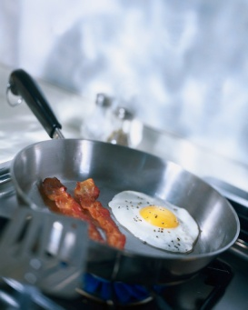
- Remove burner caps, grates, and control knobs
- Put them in your sink filled with very hot water and dishwashing detergent
- As these soak, dip a scrubbing sponge into the sink water and wring
- Go over the stovetop, paying extra attention to any stains around the burners
- Rinse with clean water; let dry
- Wipe down each of the items in the sink with your sponge
- Rinse and dry the parts; reassemble the cook top.
For an electric stove:
- For a coil electric stovetop, do this soaking method with the drip pans and knobs but not the burners, which shouldn't be submerged and are self-cleaning
- For a smooth electric stovetop, clean the surface with a nonabrasive scrubbing pad and a liquid cook top cleaner. Finally, dip a sponge in hot soapy water, wring well, and wipe the controls. Rinse and let dry.

Cleaning the oven
Inside oven
Cooked food stuck on the bottom, sides or glass of ovens can give off odours and smoke.
- Try to remove large or deep stuck food items with a metal spatula and gently chip off any loose pieces
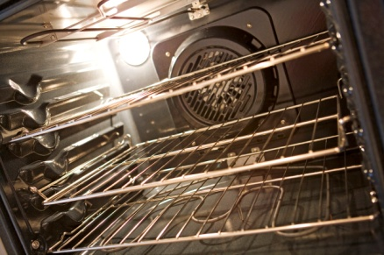
- Spray a cleaning agent on all sides on the inside or an oven
- Wipe away
- For hard to remove stains, use baking soda with a few drops of white vinegar. Let it bubble for a minute or two, and then whisk away the grime with a scrub sponge
- Rinse with a clean, wet, regular sponge.

Oven glass window
- Spray the inside of the window with appropriate cleaning agent
- Let it soak
- After a few minutes, rub down the glass with a nonabrasive scrubbing pad
- Rinse with a wet sponge, and dry with a paper towel or microfiber cloth
- Give the glass on the outside of the door a quick spray and wipe as well.

Cleaning dishwashers, washing machines and dryers
These pieces of equipment usually self clean on the inside, due to their method of operation. However it is important that they are not only clean but safe to use.
Wash the outside of the appliance, removing stains, dirt and dust.
Dishwashers
When cleaning dishwashers, ensure:
- That all items have been removed and placed away in cupboards
- That any water inside has drained away
- To clean around area where detergent has been used
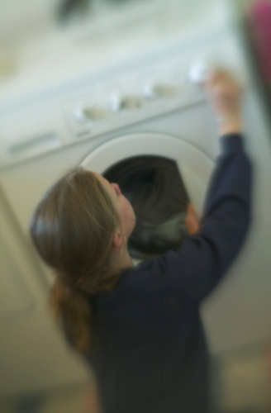
- To fill the rinse aid dispenser, if fitted.
Washing machines
When cleaning washing machines, ensure:
- That they are empty
- That if items are found in a machine, they are processed as lost property if the guest has departed, or neatly laid out for a stay over guest
- To clear away any leftover clothing strands from inside the machine.
Dryers
When cleaning dryers, ensure:
- That they are empty
- That if items are found, they are processed as lost property if the guest has departed, or neatly folded for a stay over guest
- To Clear away lint from filters and catchment areas.

Cleaning other items
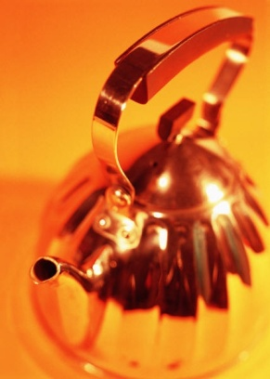
Once the major pieces of equipment have been cleaned there are other tasks to perform. These may include:
- Washing and drying pots, pans, crockery and cutlery
- Placing clean items in cupboards
- Cleaning inside cupboards and doors
- Refilling ice trays
- Cleaning kettles
- Restocking complimentary items such as tea, coffee and biscuits
- Changing drying towels and cleaning sponges
- Replenishing detergents, washing powder and cleaning agents
- Placing fresh milk in the fridge or other items as dictated by regulations
- Cleaning the microwave
- Wiping down benches and sinks
- Cleaning the floor.
Follow organisational SOP’s when performing these tasks.
Depending on the organisation, other items may also be re-stocked or stored.
When you have finished cleaning the kitchen, have a final look to ensure it is clean, tidy, dry and fully stocked.
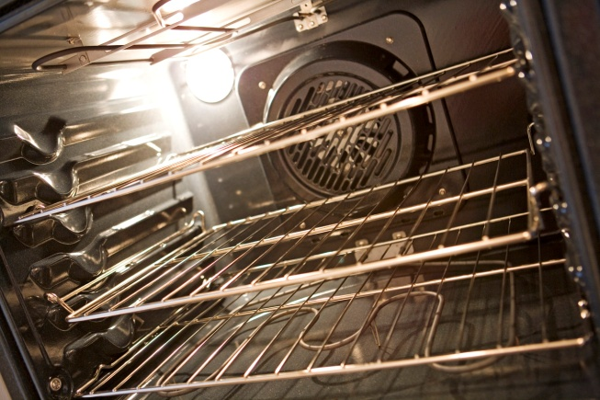

5.5 Replenish guest supplies

Introduction
Guest supplies are an important part of many guest’s stay with a property, and an on-going source of concern for venue owners and managers.
The best advice in relation to them is ‘find out what the rules are … and stick to them’.

What are ‘guest supplies’?
Depending on the establishment, there can be a number of items that will qualify as guest supplies.
The simplest definition is ‘any small item that can be used, and in some cases taken, by a guest is a guest supply’.
Examples include:
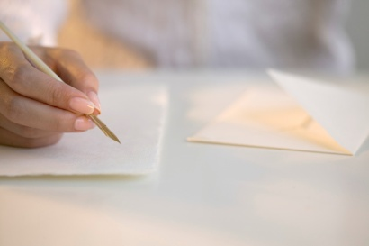
Compendium items
- Pens
- Paper
- Stationery
- Envelopes
- Fax or e-mail forms
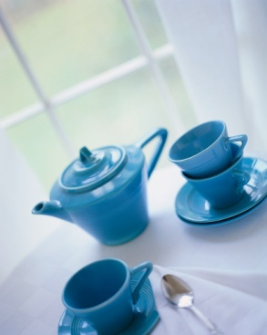

- Promotional material
- Room service menus – in traditional menu format and doorknob hangers
- Sewing and shoe polishing kits
- Guest dry-cleaning bag
- Guest laundry list
- Tea, coffee, milk and biscuits
- Iron
- Fly spray
- Additional blankets and pillows
- Remote control units
- Hair dryer
- Electric jug
- Basic cups, mugs, saucers, glasses, tea-spoons, bottle opener.


As mentioned in a previous section, where the room has a kitchen/kitchenette, the concept of room supplies expands enormously to include:
- A set number and range of cutlery and crockery
- Pots, pans and general cooking utensils
- Cleaning materials – detergent, scourers, cloths etc
- Serving plates and bowls.

Room supply basics
An integral part of preparing a guest room involves checking, replenishing or replacing room supplies.
Set numbers for these giveaway items are set by management and these must be adhered to. This is to control costs.
Despite this set quantity of give-aways per room, most properties give room attendants discretionary power to issue extras of certain items including tea, coffee, shower caps and shampoo to guests on request. Check what applies where you work and adhere to it.
If the control of give-aways is a critical issue for management, it is necessary to locate these items on your trolley in such as way that discourages unauthorised acquisition by guests. This can mean locating them on the trolley so they are not easily seen and less of a temptation.

Room supplies are for guest rooms, not for private use by staff. Using these items at work or taking them home for your personal use is theft.
Tea, coffee and sugar items as well as shampoos and conditioners must always be checked because these are items that guests seem to take with them even if they don’t use them in-room.
Pens and pads are a close second.
A double-check should be made when replenishing these items to ensure that other items have not gone missing – such as cups, saucers, bottle openers, glasses and batteries from the remote controls.

5.6 Check operational readiness of all items and equipment

Introduction
Enterprise standards as they apply to preparing rooms for guests can relate to issues such as:
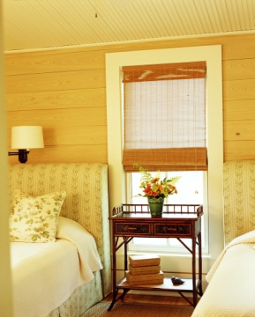
- Physical placement of items in the room
- Levels of cleanliness and tidiness
- Time allocated for servicing different types of rooms – for example, the time allocated for cleaning a standard double check-out room, as opposed to the time allocated for servicing a suite that is staying on
- Number of guest supplies of each type to be replenished
- Re-setting items in the room
- Checking the operational readiness of items.
This Section addresses the physical placement, resetting and checking the operational ability of items in a guest room

Checking operational readiness
When cleaning a check-out room, there will be standards for checking the operational readiness of items.
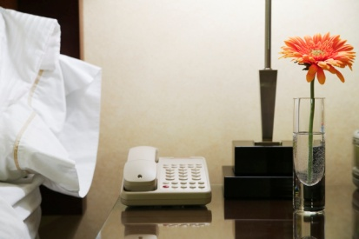
These standards aim to achieve uniformity and consistency across the establishment.
Even small things can be subject to these resetting standards. For example, some properties will require the telephone to be placed in the cradle a certain way and the telephone cord to fall to a nominated side of the unit.
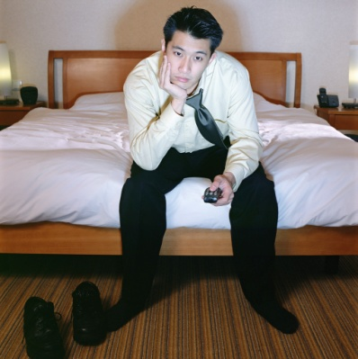
In stay rooms, house policies may require that the settings set by the guest are allowed to remain (with the possible exception of air conditioning temperatures).
For example, in an occupied room if the guest has light dimmers on a certain setting, the television on a certain channel and the volume of the radio at a certain setting – leave them as they are.
By comparison if the room is a departing room, things will need to be checked and where necessary re-set to the house standard settings.

Items included in this aspect of room servicing will include:
- In-room air conditioning set at a predetermined temperature level
- Refrigerator left at a nominated setting
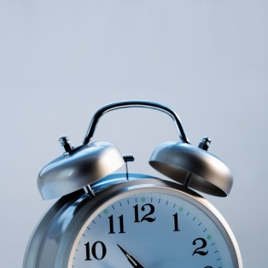
- Television set to a particular volume or channel
- Clock set to the correct time
- Alarm clock checked to ensure the alarm is not active
- Radio tuned to nominated channel and set at desired volume
- Dimmers set to medium setting
- Toaster set to desired setting
- Pens and message pads are located conveniently as required – next to bed, near telephone. All pads and pens should be laid in identical position throughout the venue.
It is vital that all items in the room are:
- Where they are meant to be
- In the correct quantity
- Operationally ready.
There is nothing more frustrating for a guest to have to ask for and then wait for something to be fixed, when it should have already been checked. This is even more frustrating for a guest who has arrived on a long flight.

5.7 Report and remedy room defects and damaged items

Introduction
Regardless of how well a room is maintained, general wear and tear will happen, equipment will break down and other problems will occur.
It is natural and while it may be annoying, guests will have a level of understanding. That said any problems with a room should be indentified and rectified before a room is allocated to a guest.
Every property wants their current guests to return to them as repeat guests and to tell their friends about how great their stay with us was so that their friends become guests who are referred to us.
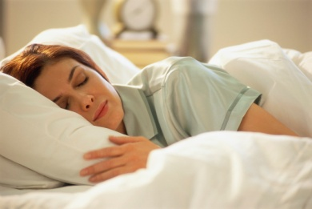
It is difficult to cultivate repeat and referral guests if their room has defects of any kind. We must always remain very much aware that in nearly all cases ‘guests have options’. If we don’t deliver the service, facilities, and standard that they want and expect, they can very easily stay somewhere else next time.
It can be a sobering research activity to check the local phone book and count the number of businesses that offer accommodation, all of which are your competitors trying to take your guests and therefore your job.

Checking for defects
Another task when servicing a guest room is to check the room for any defects in equipment, appliances, furniture or fittings.
This inspection should also check for equipment damage.
What are defects, what is damage?
Defects or damage can result from normal wear-and-tear, accidental damage or deliberate and malicious action by guests.

Where you suspect damage has been intentionally caused by guests and even guests that have already checked-out, you should reports your beliefs to your supervisor and ask them to view the damage for themselves to make a decision about what action or claims may need to be made.
In some cases, guests may be charged for the damage and clean up costs and placed on a ‘Do Not Room List’ that automatically flags a guest for refusal when their name is entered into the reservation system as a result of a query or a booking.

Defects or damage include:
- Broken fridge door seals
- Chipped or broken glasses
- Flickering fluorescent lights

- Blown light globes
- Remote controls with flat, or no, batteries
- Broken fixtures or fittings
- Refrigerators that make ‘too much’ noise – which can prevent the guest from sleeping
- Noisy air conditioning
- Dripping taps
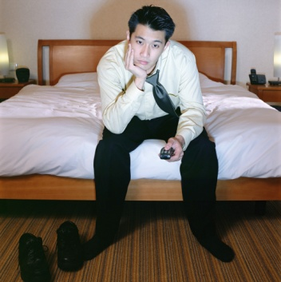
- Ripped curtains and drapes that do not properly close – allowing others to see in and unwanted light to come into the room
- Ripped, tired-looking or stained furnishings
- Fuzzy television reception
- Electric jugs and hair dryers that don’t work
- Room cards that do not easily integrate with the power controls in-room
- Irons where the temperature control settings are not working.
If a guest finds a defect in their room they may let you know about it but they may not.
If they don’t, we have just disappointed one guest and unless we identify the problem that has caused this we risk disappointing every other guest who uses that room!
Obviously this does little to generate repeat and referral guests.

What to do?
When a defect or damage to fixtures or fittings is identified, two courses of action present themselves.
The course of action chosen will depend on the seriousness of the damage and whether or not someone could be harmed because of the problem.
All action taken should be in accordance with enterprise procedures.
The two possible courses of action are:
- The item must be taken out of service immediately and replaced if possible – for example, it may be possible in the immediate short-term to replace a hair dryer that is not working (or is missing) in an occupied room with one from the floor housekeeping store or from another room that shows as vacant on your room list.

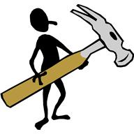
- The item is reported on a maintenance report and submitted to the appropriate person for action to be taken – where the item presents a physical danger to guests it must be removed from the room, tagged as ‘Out Of Service’ according to house procedures and stored appropriately so that it will not be returned to service before being serviced.
The motto to remember is: ‘If in doubt, have it checked out.

Record damaged items
Damaged items need to be recorded for many operational reasons.
Every property will have its own procedures for recording damaged items and room attendants are expected to comply with these where they identify such items in any guest room, and regardless of who damaged the items and how they were damaged.
Properties need to be aware of damaged items for the following reasons:
- Monitoring costs
- Determining supplies that need to be ordered
- Evaluating the usefulness of products - and determining whether or not to continue using a certain item or whether a better alternative needs to be sourced
- Identifying high damage products – to develop policies and procedures to reduce and prevent damage
- Removing them from service for OSH and duty of care reasons.

Identifying damaged items
You can become aware that an item is damaged through personal observation when you service a room – the basics are to:

- Look for damaged items – a visual inspection such as drips
- Listen for equipment that sounds as if it is damaged or not working as intended
- Be alert to smells that indicate problems – such as ‘electrical smells’
- Heed advice from guests who report such problems.
Your personal experience in the workplace will build up over time to provide you with an idea of what to look for and what items are commonly associated with damage.

Reporting the damage
Damaged or defective items must be reported so that appropriate remedial action can be taken.
Options in reporting damage include:
- Speaking face-to-face with the supervisor, Floor Housekeeper or relevant other person
- Using the in-room phone to contact and notify directly either the maintenance department or the housekeeper. Some properties have a ban on the use of guest room phones so check to see what applies in your workplace
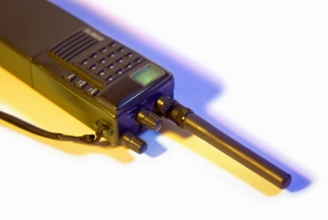
- Using other internal communication methods (pager, mobile phone) to contact and notify directly either the maintenance department or the housekeeper
- Using the in-room phone to contact reception and leave a message – see above
- Completion of a Maintenance Report identifying the damaged item, the room number, your name, and the nature of the damage.

Identifying pests
All properties should have some form of standard and establishment-wide pest control program in place.
This program usually combines the services of an external, professional pest control company with regular internal efforts at pest control.
Regular checks of rooms done by the external pest control service (with their vehicle parked around the back of the building – most people see the presence of a pest control vehicle as evidence of a pest problem as opposed to regarding it as prevention) should be at the centre of this program.
Where the established pest control program has not worked effectively and you identify pests in a guest room, immediate action needs to be taken.
Besides being undesirable from an aesthetic point of view, pests in a guest room can pose a serious health risk as well as present the potential for damage to walls and wires from gnawing.
Types of pests
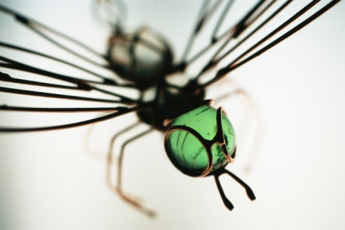
Pests include:
- Flies
- Cockroaches
- Silverfish
- Fleas
- Spiders
- Mice, rats and ants.
Signs of the presence of pests include:
- Seeing them
- Hearing them
- Seeing evidence of their presence such as droppings, spots on walls and surfaces, eggs, webs and cocoons.
Action to take
The exact action to take when pests have been sighted or are suspected must be in accordance with the house procedures that apply.
You may be required to deal on-the-spot with flies, ants, cockroaches and spiders using an aerosol spray but it is important to remember that some guests may be allergic to insect sprays so use them sparingly.
Make sure you remove the bodies! A dead fly or a dead mouse looks as bad as a live one.
Make sure you also remove any other evidence of the pests – webs, droppings.
Other pests may have to be notified to your supervisor, Head Housekeeper or the Maintenance department for them to action. This notification should be immediate to enable action to be taken as soon as possible.
Action to prevent a pest problem
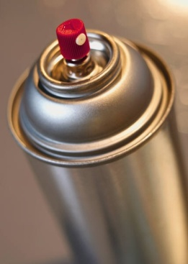
An effective pest control program requires you to do whatever you can to keep the pests out in the first place – in practice this means:
- Keeping doors and windows to guest rooms closed
- Making sure fly wire screens are fitted and in good condition
- Making sure that anything provided to a guest room is free from pests
- Control any pests you see – using aerosol sprays or other approved internal or external methods; this can be baits, traps, fogging and commercial spraying.

Apply good housekeeping techniques to deny food and drink to pests and maintain hygienic conditions – this includes:
- Never leaving food out on benches or tables
- Checking to ensure food scraps are not lying on the floor anywhere in the room – in the kitchen under the stove; under the bed
- Keeping bins clean and in good repair
- Cleaning premises thoroughly and disinfecting when necessary
- Removing all rubbish on a regular basis.
The section has highlighted the fact that problems in a guest room, whilst mostly will comprise defects and damage to physical items, there are other issues that need to be addressed to ensure the guest has a positive experience.

5.8 Report suspicious items or situations

Introduction
Accommodation establishments are the setting for many illegal activities and all room attendants must be alert for signs this is happening or may take place.
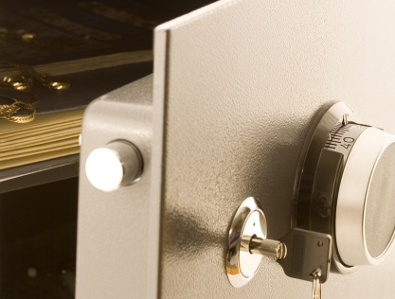
The role of a room attendant is this regard is only to ‘report’ – it is not to intervene, take action or put themselves in harm’s way.
Members of the public can target floors and rooms with a view to breaking and entering. If the thief has watched their target leave the property to go on a three-hour tour they know the target’s room will be ’safe’ for that period and it is a relatively easy target.
Other guests will use their room for illegal activities that they do not want to undertake at home.

Is the activity illegal or immoral?

Individual establishments can have different approaches this.
Most properties are not prepared to allow illegal activity and also frown on immoral activity.
Some turn a blind eye to immoral activities deeming that what guests do in the privacy of their own room is their business.
You need to speak to your supervisor to determine what applies where you work and accept the position taken by the establishment: if you ever have any concerns about differentiating between ‘illegal’ and ‘immoral’ seek guidance on the distinctions from your supervisor and be guided by them and their experience.

Taking action
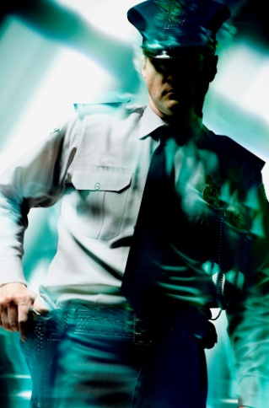
If you notice an item that looks unusual or suspicious, or see an occurrence that is suspicious, appropriate action should be taken immediately.
The appropriate action may be spelled out in the standard Emergency Procedures for your venue.
The action may be to:
- Advise the floor supervisor, the Floor Housekeeper or the Executive Housekeeper
- Contact venue security.
Always adhere to workplace policies and procedures when dealing with such matters, as they are potentially dangerous and serious.

An unusual item or situation may include:
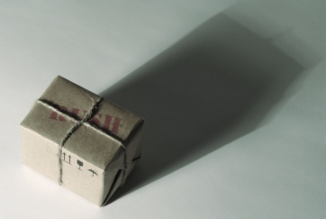
- A package left unattended in corridor or stairwells
- An item that is heavily bloodstained
- A package left in a check-out room
- A weapon found in a room – whether the room is a stay room or a departed room
- Drugs – or packages thought to contain drugs
- Explosives
- Evidence of drug taking in a room – including the presence of drug paraphernalia.
Suspicious occurrences or people may include:
- Person behaving nervously or anxiously in a corridor, stairwell, near a store room, in the guest laundry etc
- Person in an area they shouldn’t be in – such as areas members of the public in areas restricted for ‘Staff Only’ access

- Person using excessive force against another person
- Loud voices and swearing
- Sounds that indicate damage is being done
- Person seeming to loiter on a floor, along corridors, in public areas
- Person asking you to let them into a room.
If you see or hear anything that is suspicious, unusual or appears illegal you should:
- Not say anything to the persons involved

- Try not to alert them to the fact you have noticed something suspicious or unusual.
- Try to remember as much detail as possible – write down notes when safe to do so
- Alert the relevant person as soon as possible in such a way that others (those involved and other guests) cannot hear what is being said.
It is rare for you to have the authority to call police so you should refrain from doing this in all but the most extreme cases of actual or imminent danger.

5.9 Handle guest property left in room from which the guest has departed

Introduction
From time to-time departing guests leave items in their rooms.
Sometimes this is an over-sight on their part and sometimes it is intentional.
Regardless, all guest property found in a check-out room must be handled in accordance with house policy.

Dealing with lost property
There may be times when you come across items in check-out rooms that have been left behind by the guest.
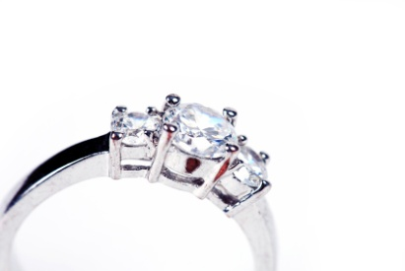
Such items should be treated as valuable in the first instance, no matter what the actual dollar worth of replacing such an item may be.
For example, a simple, partially used bottle of facial foundation, a camera, piece of clothing or an item of jewellery. They are all the same in terms of being a ‘lost and found’ item.
All such items should be taken to the housekeeping department and recorded in the ‘Lost and Found’ log book.
It is the housekeeping department’s responsibility to keep accurate records of all items found in guest rooms or public areas.
Information that needs to be recorded about the item may include:
- Date found

- Room number – or other location as appropriate (corridor, guest laundry etc.)
- Exact location in room where item was found – ‘under the bed’, ‘in the bathroom’
- Description of item – such as ‘Gent’s briefcase, brown, locked, Avon brand’, ‘ladies Seiko watch, gold with leather strap’
- Name of person who found the item
- Date item was returned to the owner - after item has been claimed or sent to the rightful owner.
Generally, lost property is kept for three months, however during that time the establishment may attempt to contact the owner, especially if the item appears valuable or the guest is a regular.
Where forwarding address or phone number is available, the guest is contacted and asked if they would like the item returned.
The guest may be asked to forward postage before the item is sent.
A ‘With Compliments’ letter generally accompanies the return of the item and a copy of this letter should be filed in the lost property correspondence file.
Some items that have not been claimed within a three-month period, after all channels to contact the owner have been exhausted, will be given back to the finder or handed to police depending on the value of the item and what it is.
Lost property should never be taken off the premises without the correct authorisation. You cannot assume that an item is yours simply because you found it and the owner has departed.

Is it ‘lost’ or has it been left on purpose?
Where the lost property is clothing (especially lingerie) or other items of a delicate nature, the decision about whether or not to contact the guest must be made with due consideration to all the possible ramifications. Tact and diplomacy may dictate that no contact is made in order to avoid embarrassment and other potential problems.
This highlights that not all items left in a guest room are ‘lost’. They may have been deliberately left there.
Perishable food
Where perishable foods are found, two options are commonly available.

The first option is that you may have discretionary powers to deal with any perishable food you find.
This may include minor quantities of things such as leftover takeaway foods, a few biscuits in an open packet, or a couple of slices of cheese, a tomato and some slices of bread left in the fridge.
If the items have been left by a departed guest, you may elect to throw out such items.
Naturally the food would be left where it is if the guest was staying on.

The second option is that Standard Operating Procedures require all staff to take all found perishable food to the Executive Housekeeper’s office, and to allow that person to make the decision.
Liquor
Again, specific house practices will vary between establishments.
Commonly, any unopened bottle of liquor – spirits, wine, beer or whatever else is logged in the standard way, and the liquor may then forwarded to the central liquor store for safe-keeping or retained in the Housekeeping office for three months.
Opened bottles may be stored in the normal Lost and Found store, or can be forwarded to another department.
It is useful to remember that what is actually inside a bottle of open beverage could be anything.

What is on the label may not be what is in the bottle so you should definitely guard against having a drink from any bottle, alcoholic or non-alcoholic, that has been already opened.
Other items
There is really no end to the nature of items that can find their way into the Lost and Found area from the very ordinary to the highly exotic!
In general terms, however, they can include:

- Inexpensive items – these must still be handed in as, despite being inexpensive, they may still have significant sentimental value. These items may include cheap pens, disposable items, handkerchiefs and socks
- Expensive items – objects of obvious worth such as cameras, lap top computers, electric razors, jewellery, cash, or clothing
- Documents – this can cover a wide range of papers including business and personal documents, as well as related items such as passports and credit cards.
Given this wide variety of items that could be found it is worth checking house rules in regard to the following:
- Newspapers, magazines and books – while it is common practice for staff to dispose of newspapers from check-out rooms, check your house rules to make sure.
Also, find out about the house rules that relate to the disposal of magazines and books. Can they be thrown out, or is there a requirement to hand them in?
What criteria apply, if any, to making the decision about keeping or throwing out these items?
- Cash – check to see if your venue has a special rule about cash that is found.
Regardless of what is considered is to be lost or found; it must be reported and recorded according to organisational requirements.
Work Projects
It is a requirement of this Unit you complete Work Projects as advised by your Trainer. You must submit documentation, suitable evidence or other relevant proof of completion of the project to your Trainer by the agreed date.
5.1 To fulfil the requirements of this Work Project you are asked to submit evidence of you being able to:
- Identify the correct order to clean a room
- Understand requirements and policies relating to cleaning rooms
5.2 To fulfil the requirements of this Work Project you are asked to submit evidence of you being able to explain or demonstrate how to:
- Clean fixtures and fittings, identifying the items and their purpose
- Vacuum floors and other areas
- Clean kitchenette area
5.3 To fulfil the requirements of this Work Project you are asked to submit evidence of you being able to explain or demonstrate how to:
- Identify and replenish guest supplies
- Check operational readiness of five items in a room
- Identify and report common defects and damaged items
- Identify and report suspicious items or situations
- Handle guest property in the correct manner

Summary

Clean room
Follow in-house requirements and policies in relation to room cleaning
- Cleaning in the correct order
- Cleaning a Check-out room
- Preparing a room for cleaning
- Cleaning an occupied room.
Clean fixtures and fittings
- Dusting and polishing
- Cleaning bins.
Vacuum floors and other areas
- Vacuuming.
Clean kitchenette area, where applicable
- Cleaning the fridge
- Cleaning the stove
- Cleaning the oven
- Cleaning dishwashers, washing machines and dryers
- Cleaning other items.
Replenish guest supplies
- What are ‘guest supplies’?
- Room supply basics.
Check operational readiness of all items and equipment
- Checking operational readiness.
Report and remedy room defects and damaged items
- Checking for defects
- What to do?
- Record damaged items
- Identifying damaged items
- Reporting the damage
- Identifying pests.

Report suspicious items or situations
- Is the activity illegal or immoral?
- Taking action.
Handle guest property left in room from which guest departed
- Dealing with lost property
- Is it ‘lost’ or has it been left on purpose?

Element 6:
Provide additional housekeeping services

6.1 Provide turn-down service

Introduction
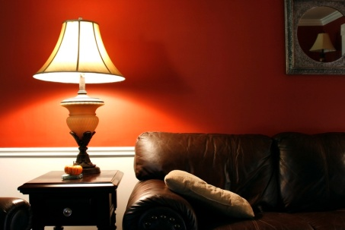
Turn down service is service commonly found in four and five star hotels. It is a service that prepares the room at the end of the day for the comfort of the guest. It is designed to make the room soothing and inviting for rest and relaxation.
Quite often a guest will be using the room during the day and by the afternoon it may be dirty or in need of fresh amenities.
‘Living’ in a hotel is different from home. Normally at home a person has a variety of rooms that they use, with clutter being spread. This is not the case in a hotel room, where only one room is used, with all activities contained within this one room.
This service is normally provided in the late afternoon or early evening and is performed at a time when it is expected that the guest is not in the room.

Turn-down steps

Preparation
The first step is to prepare the items that may be used as part of turn-down including:
- Linen – bed sheets, bath towels and pillows
- Amenities – shampoo, conditioner, hand lotion, moisturiser, sanitary items, toilet paper, tissues
- Give-aways – newspapers, chocolates, fruit, messages, flowers.

Enter the room
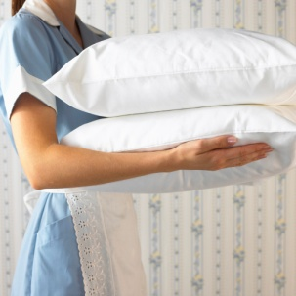
There will be a good chance the guest is in the room and may request:
- No service
- Supply of more and replacement items whilst not allowing you to enter the room
- Turn-down service as normal.

Regardless of their request it is your job to complete your tasks with minimal disruption to the guest. Time is of the essence in this situation, therefore clever thinking is required. The aim is to minimise movement and unnecessary trips in and out of the room. Plan what you are going to need.
Complete turn-down service

Normally turn-down includes:
- Closing of curtains
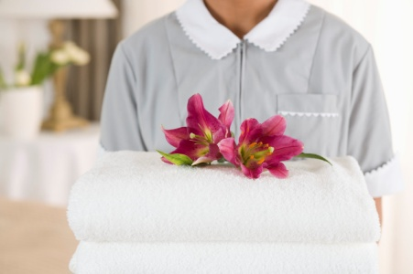
- Turning on lights to a soothing level
- Playing appropriate music through the radio or television
- Preparing the bed by removing or folding back display quilts and blankets making access to bed easier
- Placing items on the bed including fruit, messages, flowers or chocolates
- Replace dirty towels
- Clean basic and bathroom surfaces
- Clean used crockery and cutlery
- Clean bins
- Conduct a general clean and tidy.
Complete turn-down service
Once you have completed the turn-down service:
- Ask guest if they require any additional services – they may have laundry for submission
- Excuse yourself and leave the room at the earliest possible convenience.

Do Not Disturb (DND) Rooms
A number of rooms may have their DND signs out. In this case you must not knock on the door or enter the room. You should:
- Record the time
- Go back after you have completed other rooms to check if the room is ready for service
- If the DND sign is still there, slip an appropriate card under the door, requesting the guest to call housekeeping if they require turn-down at an appropriate time.
If performed correctly the turn down process should take approximately 10 minutes per room.

6.2 Carry out rotational cleaning duties

Introduction
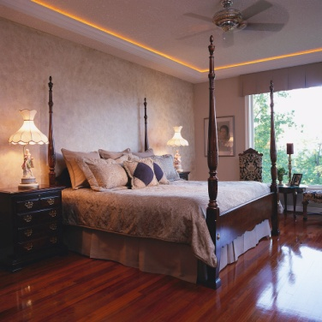
In the course of a normal day, room attendants will clean rooms as required to get a room ready for a new arrival, or to clean an occupied room. This activity is normally allocated a nominal time from between 20-40 minutes per room.
At times though, rotational cleaning duties will need to be performed which will take longer to undertake.
These activities may be classified as:
- Preventative maintenance – activities to ensure equipment furniture, fixtures and fittings are operation and effective
- Deep cleaning – activities to ensure equipment furniture, fixtures and fittings are clean.
Regardless of the activity normally these are completed at times with lower occupancy, requiring management to find tasks for full time staff that would otherwise be cleaning rooms.

Preventative maintenance
Some of these activities may include:
- Turning of mattresses – most people will sleep on one side of the mattress so mattresses will be turned around and over to ensure even use and wear
- Replacement of items – curtains, shower curtains, bedding, pillows, replacement of old appliances.

Deep cleaning
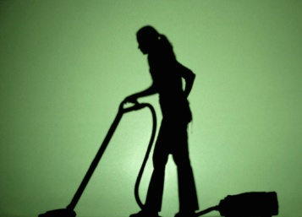
In the normal daily cleaning process whilst the guest room is cleaned, it may be ‘surface clean’ requiring a ‘deep clean’ on a regular basis.
This may include a deep cleaning of all surfaces in a room including:
Room cleaning
- Moving all furniture and ensuring it is clean underneath
- Steam cleaning of floors, furniture and curtains
- Extensive glass cleaning
- Closer attention to the baseboards ensuring all dirt is wiped clean
- Dust and clean blinds, valences or shutters
- Vacuum or clean high shelves.

Bathroom Cleaning
- Bleaching of all surfaces
- Extra attention to grouting of shower, wall and floor tiles.
Kitchen Cleaning
- Pull stove and other appliances away from wall and clean behind and under them
- Detail cabinets and pantry
- Detail kitchen drawers
- Refrigerator should be cleaned under and behind. Vacuum under the refrigerator grill and clean out hair, lint and dirt in coils
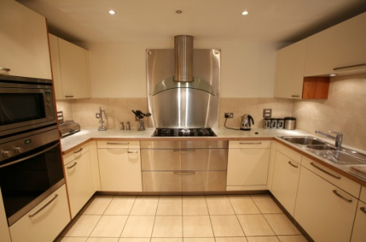
- Disinfect countertops, backsplash, front of cabinetry and under countertop appliances
- Disinfect grooves in dishwasher and stove using a small brush
- Defrost freezers
- Disinfect kitchen tidy bins.

Deodorising and spraying
All rooms should be deodorised and sprayed for insects on a regular basis.
Normally this will require a professional service with specialised equipment and may involve strong smelling or harmful chemicals. Adequate time is required for all odours to dissipate before the room can be allocated to guests.

Detail room check
After any major cleaning activity it is important that the room is ready for use.
Therefore before leaving a guest room the following items should be checked, visually inspected and confirmed:
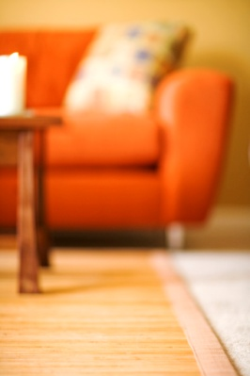
- All equipment is in correct operational order
- All equipment is re-set – clock radio, video, telephone volume, etc. Always check the alarm clock and re-set where necessary to ‘Off’; many guests have had a good night’s sleep interrupted at 4:30AM by an alarm set by the previous guest!
- All crockery, cutlery and glassware is clean and replaced
- All light bulbs are operational
- Bed has been made properly and looks attractive
- All picture frames are straight
- All furniture is in the correct location
- Bathroom is clean and all stock replenished
- Refrigerator is clean, turned on and restocked as required (fresh water, milk, ice cubes)
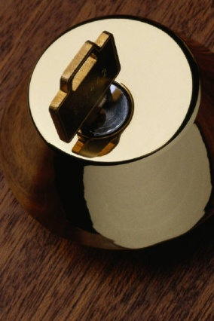
- All guest supplies (give-aways) have been restocked
- Bin liners have been replaced
- All windows are closed
- External doors to balconies are locked
- All blinds and curtains are in place
- Floor has been vacuumed
- All lights are turned off.
Anything not conforming to the standards set by the house must be addressed. There is no point doing a final check, finding a problem or area that isn’t right and then just ignoring it!

6.3 Lend equipment to guests, as requested in accordance with house policies

Introduction
It is impossible for a hotel to provide all items the guest could possibly need in all rooms. Firstly the cost would be substantial, the room would become more cluttered and the opportunity for theft would greatly increase.
Therefore most hotels will have items available for loan to guests, upon request.

Types of loan items
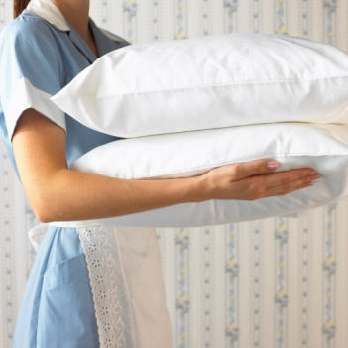
Items that are commonly loaned to customers may include:
- Special pillows
- Extra bedding
- Extra crockery and cutlery
- Cots
- Extra beds / rollway beds
- Extra furniture
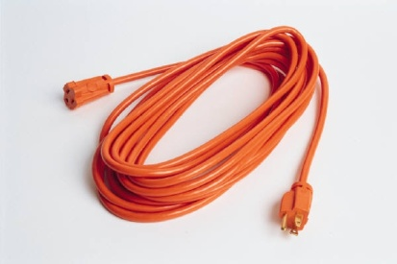
- Ice buckets
- Extra towels
- Telephone chargers
- Power boards
- Internet cables
- Video players and consoles
- Children games & toys
- DVD’s
- Books

- Iron and ironing board
- Electrical adapters
- Bath robe and weight scales
- Hair dryer
- Extra coat hangers
- Portable fans or heaters
- Picnic baskets
- Clothes drying racks.
Each operation will have its own items that it loans to guests, whether on a free of charge basis or for a fee.

Procedures for loaning items to guests
Depending on the item there are a number of steps that could be taken:
- Record item – this is to ensure that once the guest has departed the item is still in the room and accounted for and that the appropriate action is taken to return it to its appropriate storage location
- Give the item in a timely manner; this is an important service aspect. It is important to get the item as soon as possible to the guest
- Get a guest signature if an item is expensive or if there is a charge involved
- Record charges where appropriate; this is often completed at Front Office
- Ensure items have been returned.
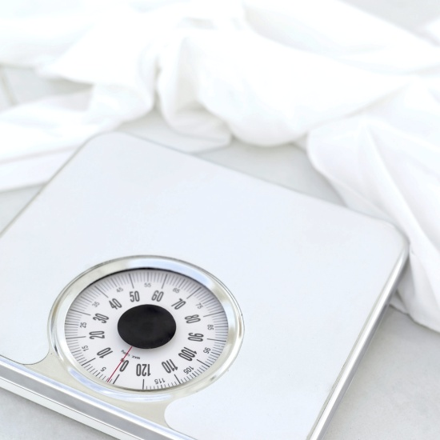
Work Projects
It is a requirement of this Unit you complete Work Projects as advised by your Trainer. You must submit documentation, suitable evidence or other relevant proof of completion of the project to your Trainer by the agreed date.
6.1 To fulfil the requirements of this Work Project you are asked to submit evidence of you being able to explain or demonstrate how to:
- Identify and perform the tasks associated with conducting a turn-down service
- Identify and perform rotational cleaning duties
- Identify the best time to conduct rotational cleaning duties.
6.2 To fulfil the requirements of this Work Project you are asked to submit evidence of you being able to identify:
- Types of items that are loaned to items
- Which items are given free of charge or for a fee
- How to ensure items are returned to its correct storage area.

Summary

Provide additional housekeeping services
Provide turn-down service
- Turn-down steps
- Do Not Disturb (DND) Rooms.
Carry out rotational cleaning duties
- Preventative maintenance
- Deep cleaning
- Detail room check.
Lend equipment to guests, as requested in accordance with house policies
- Types of loan items
- Procedures for loaning items to guests.

Element 7:
Prepare for next shift

7.1 Complete required records and notifications

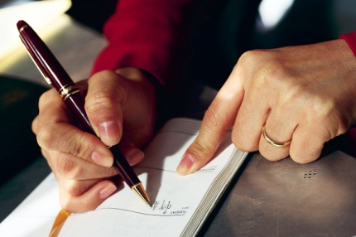
Introduction
The role of a room attendant is relatively free from paperwork and reports; however there are some records that need to be updated by room attendants as part of their job.
As room attendants work alone or in pairs for the majority of their shift, written communication is vital to ensure information is recorded and shared with other housekeeping team members.

Types of records and notifications
Some of the records and notifications written by room attendants on a daily basis include:
- Recording status of rooms
- Lost property reports
- Ordering of supplies
- Handover reports – information required for the next shift, including turn-down rooms to complete and incidents that occurred that day
- Records of items that were loaned to guests
- Maintenance requests
- Time sheets.
Each workplace may have additional forms that need to be completed to suit the requirements of their role.

7.2 Dispose of rubbish

Introduction
Housekeeping is all about cleanliness and tidiness and this should not stop at the end of the day.
The general cleanliness and hygiene of a hospitality business is vital to the health of all stakeholders including staff, guests, owners and the community in general.
In reality, taking care when handling and disposing of rubbish is vital for a number of reasons including:
- A clean environment is aesthetically pleasing
- Reduction of accidents caused by people tripping and falling over
- Reduction of the chance of contamination
- Reduction of unpleasant odours
- Attraction of fewer insects and rodents
- Reduced likelihood of contamination.
All staff have a responsibility to dispose of rubbish in a way that poses minimal hazards to all stakeholders. Anyone who handles rubbish is at risk or injury and illness if it is not handled correctly.

Types of rubbish
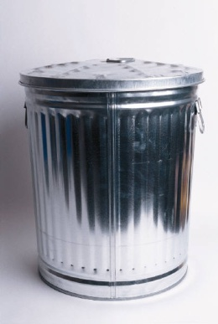
There are two main types of rubbish in hospitality environments:
General Rubbish
This is similar to household rubbish and is the type of rubbish most found in hospitality organisations and guest rooms. It includes:
- Paper and boxes
- Bottles
- Plastic containers
- Food and beverage related trash.
Hazardous Rubbish
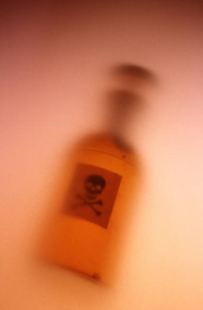
This is rubbish that can be harmful and should be treated carefully. It includes:
- Chemicals
- Broken glass
- Cleaning products
- Disinfectants
- Unknown bottles and liquids.

Handling rubbish
Staff should handle rubbish as little as possible before disposal. Special care must be taken when handling hazardous rubbish. It may require special bags or boxes (in the case of broken glass).
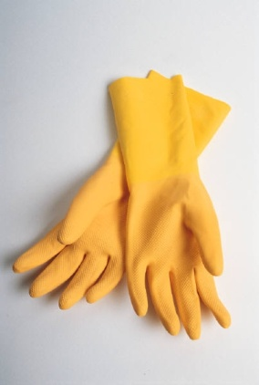
It is always advisable to:
- Wear gloves when handling rubbish
- Not overload rubbish bags or bins
- Use safe manual handling techniques
- Use a trolley to move rubbish where necessary
- Dispose of rubbish in a timely manner
- Move rubbish to disposal areas during quiet times or on quiet routes
- Place rubbish in suitable disposal areas – this includes the separation of paper, glass and plastic based products.
The efficient and effective removal of rubbish is key to maintaining a clean and tidy workplace.

7.3 Clean and store trolleys

Introduction
Your work as a room attendant does not finish when you complete servicing the last room allocated to you.
Before you leave, there are several end-of-shift duties that will need to be completed.
This Section looks at the need to clean your housekeeping trolley that was used during the room servicing procedures
After every use you are responsible for cleaning and restocking the trolley you have used during the cleaning activities.

Cleaning the housekeeping trolley
Generally a wipe over assisted by a general purpose cleaner should suffice, with extra spot-cleaning as required.
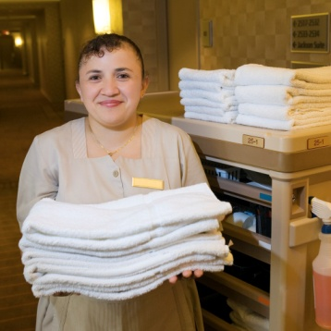
The intention is to remove any marks that the trolley may have and to maintain its attractive appearance. You may need to replace used or dirty linen and rubbish bags that are provided at end of the trolley to maintain eye appeal.
Attention should also be paid to:
- Removing any soiled items
- Removing any empty packages.

Restock the housekeeping trolley
The trolley is not unloaded at the end-of-shift. Items that are on the trolley when it returns to the storeroom are left on it.
It is important that you restock your trolley so that it is ready for the next shift.
Each organisation will have different items that need to be placed on the trolley.

7.4 Replenish stock items as necessary

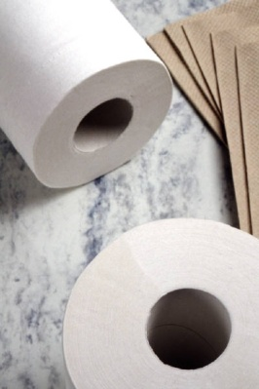
Introduction
One of the last tasks you will be required to do at the end of a shift is to check the supplies that exist in the housekeeping store.
You may be required to order extra supplies, or replenish them.

Reordering stock and supplies
Your experience coupled with any management guidelines relating to the levels of stock to be kept in a housekeeping storeroom will assist in determining whether or not stock or supplies need to be ordered.
The aim of maintaining stock and supplies in a housekeeping store is that you never run out of anything but you don’t over-stock
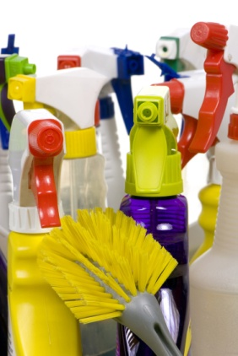
Housekeeping trolleys can be stocked at the beginning or end of each shift, but it is preferable that they are fully re-stocked at the end of the day’s work, so the trolley is prepared for the next shift, and so that missing items are able to be bought in before the next shift.
When supplies run low during a shift, further supplies may be accessed from the housekeeping store room. There is generally one on each floor which must be kept locked to prevent unauthorised access.
When supplies in the floor housekeeping store room run low, further supplies can be brought up from the housekeeping department where there is usually some form of central store purely for housekeeping supplies.
When requesting supplies you may be required to complete a requisition form.
The requisition form is an internal stock ordering form that you fill in and give to the Head Housekeeper (or other nominated person).
It will identify:
- Person requesting the items
- Type of items needed
- Quantity
- Date.

The majority of housekeeping departments will have a standard order/requisition form.
Requisition forms that are completed and forwarded to the Head Housekeeper at the end of shift today, should result in the supplies that have been ordered or ‘requisitioned’ being supplied to the appropriate floor housekeeping store/linen room later that day or early the next day before the next shift starts work.

What should be checked to replenish or reorder?
In short, ‘everything’.
The housekeeping store often contains a multitude of items over and above the room and guest supplies that have been mentioned elsewhere in these notes.
It is not uncommon to find one or a few of the following in most housekeeping stores:
- Light globes
- Batteries for remote controls
- Ash trays
- Glasses
- An assortment of cutlery and crockery – plus an assortment of cooking items where rooms have a kitchenette
- Safety pins and drawing pins
- Spare electric blankets, irons, ironing board covers, hair dryers, electric jugs etc
- Ice cube trays.
Where you have run out of any of the above or you suspect stocks are below what can reasonably be needed, you should requisition or reorder them.



7.5 Clean housekeeping equipment prior to storage

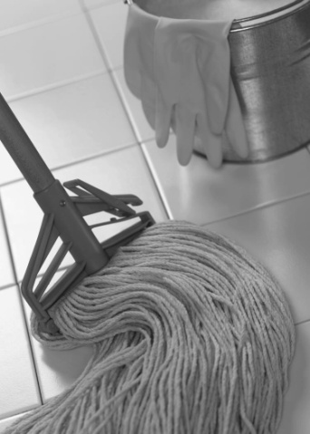
Introduction
Now that the storage areas are maintained and restocked it is important to ensure that all housekeeping equipment is clean and ready for the next shift.
Following is a brief description of how different equipment can be cleaned and stored.

Equipment to be cleaned

Mops
Procedures for cleaning of the three main types of mops are as follows:
- Dusting mops – after use, shake thoroughly in appropriate location (outside) then wash in hot soapy water, and hang out to air dry
- Polishing mops – on a regular basis, remove fluff and rinse mop in turpentine, which will remove the polish – after the mop has been squeeze-dried, re-coat with polish
- Washing mops – on a regular basis mops should be washed in hot soapy water, rinsed thoroughly, squeeze-dried, and then hung up to air dry.

Dusters
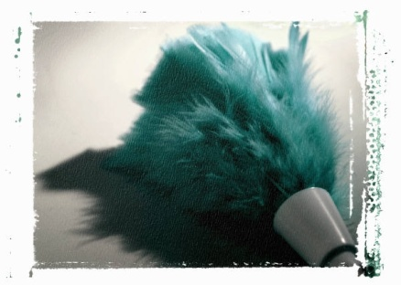
Cleaning of dusters involves:
- Shaking clean regularly in an appropriate outside location
- Washing in accordance with the manufacturer’s instructions – the laundry will be responsible for this: you will be required to leave all used dusters and cleaning cloths in a nominated location for the laundry porter to pick up.

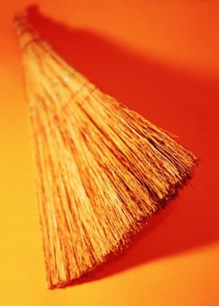
Brooms and brushes
Cleaning of brooms and brushes may vary with special items but the general approach is:
- Shake clean in an outside location
- Wash with designated detergent – some properties will also require sanitising
- Hang to air dry.

Cloths and sponges
Clothes may be given to the laundry for cleaning, or you may have to do your own: the increasing use of disposable cloths has reduced the need to clean these.
Where you have to clean your own:
- Wash with designated detergent – some properties will also require sanitising
- Air dry.

Buckets
A dedicated bucket wash area complete with purpose-built sink and grate (for resting the bucket on) may be available – buckets may also be filled at this location.
Cleaning involves:
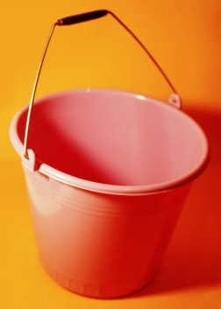
- Tipping out the dirty water into the sink or gully trap identified for this purpose – buckets should not be emptied in the guest room
- Removing or rinsing out any dirt and material
- Washing with designated detergent – some properties will also require sanitising
- Checking rollers and removing debris as required – clean rollers with cloth
- Turning upside down and leaving to air dry.

Vacuum cleaners
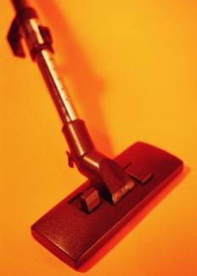
All vacuum cleaners must be cleaned out at the end of the shift and the bag replaced if required.
The machine and its attachments must be wiped clean using a damp cloth.
The power cord should be wrapped correctly and safely.
All cleaning of vacuum cleaners must be done in accordance with manufacturer’s instructions.

Where does this happen?
This cleaning is usually done in the room where the trolleys are kept at the end of shift. The floor housekeeping store, or there may be a need to take the trolley to some remote dedicated cleaning area.
Equipment is cleaned after use so as to:
- Maintain a high level of appearance –equipment is seen by many guests who may reach a decision about our cleaning procedures based on the trolleys they see in the corridors
- Maximise their operational effectiveness
- Leave the items ready for use.

Location for storing equipment
In general:
- Large items – vacuum cleaners, brooms, buckets – go on the floor
- Smaller items go on shelves – shelves often have labels to show what goes where.
Everything has its nominated position in the storeroom to:
- Make it easy to see what is left and how much is left
- Allow all room attendants to quickly obtain what they want – remember that others will also be using this store
- Facilitate stocktaking activities.

Checks to make when storing equipment
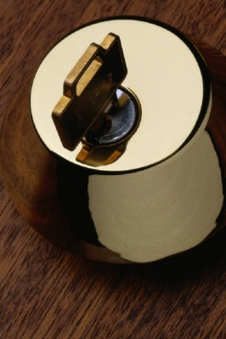
When storing equipment, check the following:
- All minor or major faults and repair needs have been identified and acted upon
- All equipment has been cleaned – and where appropriate, dried
- Electrical cords are rolled up and positioned safely and securely
- Every piece of equipment and every cleaning item is stored safely (that is, so as not to pose a risk to staff) and in the appropriate location
- The door to the storeroom is locked when you leave.

Finally
Go to the Head Housekeeper’s office and:
- Advise that you have finished and about to go – this is a good practice because it allows you to be informed about other needs. It is also polite and expected staff behaviour. Don’t just go home without telling anyone you are going

- Notify the office of any problems you have identified or any suspicions etc you have. This includes submitting any requisitions, requests, reports, forms etc.
- Hand back and sign in your room keys or cards
- Complete your time sheet.
Once you have completed this task you have successfully completed your shift.
As this manual demonstrates, the role of a room attendant is a hard job requiring a special person with a wide range of knowledge, skills and attributes.
The room attendant is truly the spine of the hospitality industry.
Work Projects
It is a requirement of this Unit you complete Work Projects as advised by your Trainer. You must submit documentation, suitable evidence or other relevant proof of completion of the project to your Trainer by the agreed date.
7.1 To fulfil the requirements of this Work Project you are asked to submit evidence of you being able to explain or demonstrate how to:
- Complete required records and notifications
- Dispose of rubbish in a safe and efficient manner
- Clean and store trolleys including the identification of items to be restocked on trolleys.
7.2 To fulfil the requirements of this Work Project you are asked to submit evidence of you being able to explain or demonstrate how to:
- Replenish stock items
- Order stock items and the procedures normally involved.
7.3 To fulfil the requirements of this Work Project you are asked to submit evidence of you being able to explain or demonstrate how to:
- Clean housekeeping equipment
- Describe how and where they should be kept.

Summary

Prepare for next shift
Complete required records and notifications
- Types of records and notifications.
Disposal of rubbish
- Types of rubbish
- Handling rubbish.
Clean and store trolleys
- Cleaning the housekeeping trolley
- Restock the housekeeping trolley.
Replenish stock items as necessary
- Reordering stock and supplies
- What should be checked to replenish or reorder?
Clean housekeeping equipment prior to storage
- Equipment to be cleaned
- Where does this happen?
- Location for storing equipment
- Checks to make when storing equipment.

Presentation of written work

1. Introduction
It is important for students to present carefully prepared written work. Written presentation in industry must be professional in appearance and accurate in content. If students develop good writing skills whilst studying, they are able to easily transfer those skills to the workplace.

2. Style

Students should write in a style that is simple and concise. Short sentences and paragraphs are easier to read and understand. It helps to write a plan and at least one draft of the written work so that the final product will be well organised. The points presented will then follow a logical sequence and be relevant. Students should frequently refer to the question asked, to keep ‘on track’. Teachers recognise and are critical of work that does not answer the question, or is ‘padded’ with irrelevant material. In summary, remember to:
- Plan ahead
- Be clear and concise
- Answer the question
- Proofread the final draft.

3. Presenting Written Work
Types of written work
Students may be asked to write:
- Short and long reports
- Essays
- Records of interviews
- Questionnaires
- Business letters
- Resumes.
Format
All written work should be presented on A4 paper, single-sided with a left-hand margin. If work is word-processed, one-and-a-half or double spacing should be used. Handwritten work must be legible and should also be well spaced to allow for ease of reading. New paragraphs should not be indented but should be separated by a space. Pages must be numbered. If headings are also to be numbered, students should use a logical and sequential system of numbering.
Cover Sheet
All written work should be submitted with a cover sheet stapled to the front that contains:
- The student’s name and student number
- The name of the class/unit
- The due date of the work
- The title of the work
- The teacher’s name
- A signed declaration that the work does not involve plagiarism.
Keeping a Copy
Students must keep a copy of the written work in case it is lost. This rarely happens but it can be disastrous if a copy has not been kept.
Inclusive language
This means language that includes every section of the population. For instance, if a student were to write ‘A nurse is responsible for the patients in her care at all times’ it would be implying that all nurses are female and would be excluding male nurses.
Examples of appropriate language are shown on the right:
Mankind | Humankind
Barman/maid | Bar attendant
Host/hostess | Host
Waiter/waitress | Waiter or waiting staff

Recommended reading
Casado, Matt A.; 2011 (2nd edition); Housekeeping Management (CourseSmart); Wiley
Jones, Thomas J. A. 2007 (5th edition); Professional Management of Housekeeping Operations; Wiley
Nitschke, Aleta A. 2008 (3rd edition); Managing Housekeeping Operations; Educational Institute of the American Hotel Motel Association
Kappa, Margaret M., 1997 (2nd edition); Housekeeping Management; Educational Institute of the American Hotel Motel Association
O'Fallon, Michael J.; 2010 (5th edition); Hotel Management and Operations; Wiley
Powell, P. Hunter and Watson, D; 2006; Service unseen: The hotel room attendant at work; An article from: International Journal of Hospitality Management

Trainee evaluation sheet

Clean and prepare rooms for incoming guests
The following statements are about the competency you have just completed.
Please tick the appropriate box | Agree | Don’t Know | Do Not Agree | Does Not Apply
There was too much in this competency to cover without rushing.
Most of the competency seemed relevant to me.
The competency was at the right level for me.
I got enough help from my trainer.
The amount of activities was sufficient.
The competency allowed me to use my own initiative.
My training was well-organized.
My trainer had time to answer my questions.
I understood how I was going to be assessed.
I was given enough time to practice.
My trainer feedback was useful.
Enough equipment was available and it worked well.
The activities were too hard for me.

The best things about this unit were:

The worst things about this unit were:

The things you should change in this unit are:

Trainee self-assessment checklist
As an indicator to your Trainer/Assessor of your readiness for assessment in this unit please complete the following and hand to your Trainer/Assessor.

Clean and prepare rooms for incoming guests
 |  | Yes | No*
Element 1: Identify the role of room attendants
1.1 | Describe the services delivered by a room attendant
1.2 | Locate the position of room attendants within the enterprise
1.3 | Identify the personal characteristics required of a room attendant
1.4 | Describe grooming and personal presentation standards for a room attendant
1.5 | Interpret enterprise policies and procedures for the provision of housekeeping services
1.6 | Identify and explain the role of communication in the provision of housekeeping services
Element 2: Prepare for cleaning duties
2.1 | Replenish linen room supplies
2.2 | Load housekeeping trolley with supplies for service
2.3 | Check housekeeping trolley prior to use
2.4 | Identify rooms to be cleaned for the shift
2.5 | Access and enter guest room appropriately
Element 3: Make beds
3.1 | Strip and re-make bed with fresh bed linen
3.2 | Re-make bed using existing bed linen
Element 4: Clean bathroom
4.1 | Clean bath and shower area
4.2 | Clean toilets
4.3 | Clean vanity area
4.4 | Clean floors
4.5 | Replenish guest supplies
Element 5: Clean room
5.1 | Follow in-house requirements and policies in relation to room cleaning
5.2 | Clean fixtures and fittings
5.3 | Vacuum floors and other areas
5.4 | Clean kitchenette area, where applicable
5.5 | Replenish guest supplies
5.6 | Check operational readiness of all items and equipment
5.7 | Report and remedy room defects and damaged items
5.8 | Report suspicious items or situations
5.9 | Handle guest property left in room from which guest departed
Element 6: Provide additional housekeeping services
6.1 | Provide turn-down service
6.2 | Carry out rotational cleaning duties
6.3 | Lend equipment to guests, as requested in accordance with house policies
Element 7: Prepare for next shift
7.1 | Complete required records and notifications
7.2 | Dispose of rubbish
7.3 | Clean and store trolleys
7.4 | Replenish stock items as necessary
7.5 | Clean housekeeping equipment prior to storage
Statement by Trainee:
I believe I am ready to be assessed on the following as indicated above:
Signed: _____________________________ | Date: ____________

Note:
For all boxes where a No* is ticked, please provide details of the extra steps or work you need to do to become ready for assessment.





